Hardening Apache 2.4 & PHP 5 on FreeBSD
Added by Daniel Curtis about 3 years ago. Updated almost 3 years ago.
Status:
Closed
Priority:
Normal
Assignee:
Daniel Curtis
Category:
Web Server
Target version:
FreeBSD 9
Start date:
02/13/2015
Due date:
% Done:
100%
Estimated time:
3.00 h
Spent time:
3.50 h

Description
- Harden Apache 2.4
  - Remove Server information on error page
  - Disable Directory Listing
  - Enhance security on Apache rewrite
  - Install mod_security
  - Install mod_evasive
- Harden PHP
  - Restrict PHP leakage
  - Log All PHP Errors
  - Disable File Uploads
  - Disabling Dangerous PHP Functions
- Resources
This is a simple guide for hardening the default settings of Apache and PHP on FreeBSD 9.2. I use a combination of some or all of the following configurations in my production systems.
- Update the system and ports tree:
pkg update && pkg upgrade
portsnap fetch extract
- Install git:
pkg install git

Harden Apache 2.4

Remove Server information on error page
- Disallow server to print out any Apache information on error pages.
vi /usr/local/etc/apache24/httpd.conf
  - Add/modify the following lines as following:
## Prevent apache from sending identifying information
ServerTokens Prod
ServerSignature Off

Disable Directory Listing
- Edit the httpd.conf file
vi /usr/local/etc/apache24/httpd.conf
  - Then add a minus "-" before the "Indexes" and it should be look like that after modification:
<Directory /usr/local/www/apache24/data>
## Disable Indexes option
Options -Indexes FollowSymLinks MultiViews
AllowOverride None
Order allow,deny
allow from all
</Directory>

Enhance security on Apache rewrite
- In order to prevent Cross-Site-Tracing attacks, the following lines to be added within each <VirtualHost *:80> block
## Prevent Cross-Site-Tracing attacks
<IfModule mod_rewrite.c>
RewriteEngine On
RewriteCond %{REQUEST_METHOD} ^(TRACE|TRACK)
RewriteRule .* - [F]
</IfModule>
  - To test if it is working properly run:
curl -X TRACE www.example.com
  - Example output:
<!DOCTYPE HTML PUBLIC "-//IETF//DTD HTML 2.0//EN">
<html><head>
<title>403 Forbidden</title>
</head><body>
<h1>Forbidden</h1>
<p>You don't have permission to access /
on this server.<br />
</p>
</body></html>

Install mod_security
ModSecurity is an open source, cross-platform web application firewall (WAF) module. Known as the "Swiss Army Knife" of WAFs, it enables web application defenders to gain visibility into traffic and provides a power rules language and API to implement advanced protections.
- Install mod_security
pkg install ap24-mod_security
- ModSecurity requires firewall rule definitions. Most people use the OWASP ModSecurity Core Rule Set (CRS). The easiest way to track the OWASP CRS repository right now is to use Git. Let's make a directory for all our ModSecurity related stuff, and clone the CRS repository under it
mkdir -p /usr/local/etc/modsecurity && cd /usr/local/etc/modsecurity
git clone https://github.com/SpiderLabs/owasp-modsecurity-crs crs
- Copy the default ModSecurity config file:
cp /usr/local/etc/modsecurity.conf-example /usr/local/etc/modsecurity/modsecurity.conf
- And fetch a necessary file which is currently not included in the port:
fetch https://raw.github.com/SpiderLabs/ModSecurity/master/unicode.mapping
- Copy the default ModSecurity CRS config file:
cp crs/modsecurity_crs_10_setup.conf.example modsecurity_crs_10_setup.conf
- Now create an Apache configuration snippet in Apache's httpd.conf file. It loads the ModSecurity module, and includes the configurations and CRS:
vi /usr/local/etc/apache24/httpd.conf
  - And add/modify the following
## Load security module
LoadModule security2_module libexec/apache22/mod_security2.so

## Configure security module
<IfModule security2_module>
# Include ModSecurity configuration
Include /usr/local/etc/modsecurity/modsecurity.conf

# Include OWASP Core Rule Set (CRS) configuration and base rules
Include /usr/local/etc/modsecurity/modsecurity_crs_10_setup.conf
Include /usr/local/etc/modsecurity/crs/base_rules/*.conf

# Add custom configuration and CRS exceptions here. Example:
# SecRuleRemoveById 960015
</IfModule>
- When the configuration is all set, simply restart Apache:
service apache24 restart
  - Confirm that ModSecurity is loaded by checking Apache's log file:
tail /var/log/httpd-error.log
  - Example output:
ModSecurity for Apache/2.7.7 (http://www.modsecurity.org/) configured.
ModSecurity: APR compiled version="1.4.8"; loaded version="1.4.8"
ModSecurity: PCRE compiled version="8.34 "; loaded version="8.34 2013-12-15"
ModSecurity: LIBXML compiled version="2.8.0"
- Blocking mode can be enabled by editing modsecurity.conf and changing the following line:
SecRuleEngine On
  - And restart apache to apply it:
service apache24 restart
- Keep the CRS updated from time to time:
cd /usr/local/etc/modsecurity/crs
git pull

Install mod_evasive
mod_evasive is an evasive maneuvers module for Apache to provide evasive action in the event of an HTTP DoS or DDoS attack or brute force attack. It is also designed to be a detection and network management tool, and can be easily configured to talk to ipchains, firewalls, routers, and etcetera. mod_evasive presently reports abuses via email and syslog facilities.
- Edit the mod_evasive Makefile:
cd /usr/ports/www/mod_evasive
vi Makefile
  - And change the line USE_APACHE=22 to:
USE_APACHE= 24
- Begin compilation:
make install clean
  - Currently the port will fail with output similar to the following:
mod_evasive20.c: In function 'access_checker':
mod_evasive20.c:142: error: 'conn_rec' has no member named 'remote_ip'
mod_evasive20.c:146: error: 'conn_rec' has no member named 'remote_ip'
mod_evasive20.c:158: error: 'conn_rec' has no member named 'remote_ip'
mod_evasive20.c:165: error: 'conn_rec' has no member named 'remote_ip'
mod_evasive20.c:180: error: 'conn_rec' has no member named 'remote_ip'
mod_evasive20.c:187: error: 'conn_rec' has no member named 'remote_ip'
mod_evasive20.c:208: error: 'conn_rec' has no member named 'remote_ip'
mod_evasive20.c:212: warning: implicit declaration of function 'getpid'
mod_evasive20.c:215: error: 'conn_rec' has no member named 'remote_ip'
mod_evasive20.c:221: error: 'conn_rec' has no member named 'remote_ip'
mod_evasive20.c:222: error: 'conn_rec' has no member named 'remote_ip'
mod_evasive20.c:228: error: 'conn_rec' has no member named 'remote_ip'
apxs:Error: Command failed with rc=65536
.
*** [do-build] Error code 1

Stop in /usr/ports/www/mod_evasive.
- Fix the working mod_evasive source code:
sed -i '' -e 's/remote_ip/client_ip/g' work/mod_evasive/mod_evasive20.c
- Then finish installing mod_evasive:
make install clean
- Edit the Apache httpd.conf file:
vi /usr/local/etc/apache24/httpd.conf
  - And add the following:
## Load evasive module
LoadModule evasive20_module libexec/apache24/mod_evasive20.so

## Configure evasive module
<IfModule evasive20_module>
#increases size of hash table. Good, but uses more RAM.
DOSHashTableSize 3097
#Interval, in seconds, of the page interval.
DOSPageInterval 1
#Interval, in seconds, of the site interval.
DOSSiteInterval 1
#period, in seconds, a client is blocked. The counter is reset to 0 with every access within this interval.
DOSBlockingPeriod 10
#threshold of requests per page, per page interval. If hit == block.
DOSPageCount 2
#threshold of requests for any object by the same ip, on the same listener, per site interval.
DOSSiteCount 50
#locking mechanism prevents repeated calls. email can be sent when host is blocked (leverages the following by default "/bin/mail -t %s")
DOSEmailNotify admin@example.com
#locking mechanism prevents repeated calls. A command can be executed when a host is blocked. %s is the host IP.
#DOSSystemCommand "su - someuser -c '/sbin/... %s ...'"
#DOSLogDir "/var/lock/mod_evasive"
#whitelist an IP., leverage wildcards, not CIDR, like 127.0.0.*
#DOSWhiteList 127.0.0.1
</IfModule>
- Restart apache24 to enable mod_evasive
service apache24 restart

Harden PHP

Restrict PHP leakage
- To restrict PHP information leakage disable expose_php. Edit the php.ini file and set the following directive:
vi /usr/local/etc/php.ini
  - And modify the following parameter:
expose_php=Off

Log All PHP Errors
- Do not expose PHP error messages to all site visitors. Edit php.ini and set the following directive:
display_errors=Off
- Make sure you log all php errors to a log file:
log_errors=On
error_log=/var/log/php-error.log

Disable File Uploads
- Edit php.ini and set the following directive to disable file uploads for security reasons:
file_uploads=Off
- If users of your application need to upload files, turn this feature on by setting upload_max_filesize limits the maximum size of files that PHP will accept through uploads:
file_uploads=On
# user can only upload upto 1MB via php
upload_max_filesize=1M

Disabling Dangerous PHP Functions
- PHP has a lot of functions which can be used to crack your server if not used properly. You can set list of functions in php.ini using disable_functions directive:
disable_functions =exec,passthru,shell_exec,system,proc_open,popen,curl_exec,curl_multi_exec,parse_ini_file,show_source

Resources
http://www.cyberciti.biz/tips/php-security-best-practices-tutorial.html
http://www.cyberciti.biz/faq/freebsd-install-configure-mod_security/
https://lifeforms.nl/20140221/install-modsecurity-freebsd/
http://www.ansoncheunghk.info/article/7-simple-steps-harden-apache-and-php-linux
https://github.com/SpiderLabs/ModSecurity/wiki/Reference-Manual
https://github.com/SpiderLabs/owasp-modsecurity-crs
https://forums.freebsd.org/threads/mod_evasiv.48806/
https://mbrownnyc.wordpress.com/technology-solutions/create-a-secure-linux-web-server/install-and-configure-mod_evasive-for-apache-2-4-x/

FreeBSD Install and Configure Apache Web Server
in Categories Apache, FreeBSD, Networking, Package Management, PF Firewall, UNIX last updated October 8, 2008
Q. How do I install and configure Apache web server under FreeBSD 7.x operating systems?
A. FreeBSD comes with various versions of Apache web servers:
=> Apache 1.3
=> Apache 2.0
=> Apache 2.1
=> Apache 2.2

Step # 1: Update FreeBSD ports collection
Type the following command to update FreeBSD ports collection:
# portsnap fetch update

Step # 2: Install Apache Web Server
Type the following commands:
# cd /usr/ports/www/apache22/
# make install clean
Select required options:
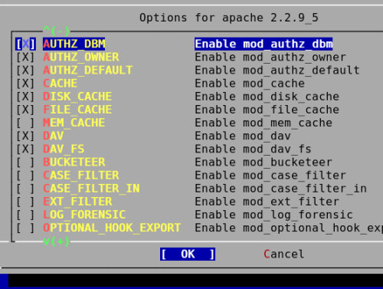

Step 3: FreeBSD Configure Apache
Quick facts about Apache version 2.2 under FreeBSD:
- Default HTTP port: 80
- Default HTTPS (SSL) port: 443
- Default DocumentRoot directory: /usr/local/www/apache22/data/
- Default cgi-bin directory: /usr/local/www/apache22/cgi-bin/
- Default Error Log File: /var/log/httpd-error.log
- Default Access Log File: /var/log/httpd-access.log
- Default suexec log (if compiled with suexec): /var/log/httpd-suexec.log
- Default configuration file directory:/usr/local/etc/apache22/ and /usr/local/etc/apache22/extra/
- Default configuration file: /usr/local/etc/apache22/httpd.conf

Turn on Apache service
Type the following command to turn on Apache22 service:
echo 'apache22_enable="YES"' >> /etc/rc.conf

Configure httpd.conf
Open httpd.conf file:
# cp /usr/local/etc/apache22/httpd.conf /root/httpd.conf.bak
# vi /usr/local/etc/apache22/httpd.conf
Bind Apache to specific IP addresses and/or ports, instead of the default. Let us bind to IP address called 202.4.2.1 and port 80:
Listen 202.4.2.1:80
Set your email address:
ServerAdmin vivek@nixcraft.com
Set servername (FQDN) such as www.nixcraft.com:
ServerName www.nixcraft.com
Save and close the file.

Start Apache server
To start Apache server v2.2, enter:
# /usr/local/etc/rc.d/apache22 start
Verify that port 80 is opened:
# sockstat -4 | grep :80

Open port 80 using PF firewall
WARNING! These examples may block access to your computer if not executed properly. If you are configuring FreeBSD and Apache first time, I strongly recommend skipping this step.
PF is OpenBSD firewall and available under FreeBSD. You need to configure pf using /etc/pf.conf file. Add following line to your /etc/pf.conf file:
pass in on $ext_if proto tcp from any to 202.4.2.1 port 80 flags S/SA synproxy state
Save and close the file. Reload pf firewall:
# /etc/rc.d/pf reload

Test your new setup
Fire a webbrowser and type your domain name such as www.nixcraft.com.

Posted by: Vivek Gite
The author is the creator of nixCraft and a seasoned sysadmin, DevOps engineer, and a trainer for the Linux operating system/Unix shell scripting. Get the latest tutorials on SysAdmin, Linux/Unix and open source topics via RSS/XML feed or weekly email newsletter.

10 Apache Security and Hardening Tips
By yuli | August 3, 2017
0 Comments
The Apache web server is a crucial part of the website infrastructure. It has a number of built in features that can improve your website resistance to attacks. The following document covers a number of steps that will help you to achieve this goal.
*** This document was originally published in 2013, so, it is a bit outdated.

Tip No. 1: Disable Apache Signature and/or Apache Banner
Apache Signature or Apache Banner is basically the same thing. It is an application name together with version name that is printed when performing a web request. Nobody actually needs this information at all, but it is enabled by default. You need to alter the Apache configuration file to disable it.
ServerSignature Off
ServerTokens ProductOnly
In Ubuntu, you need to change the following file: /etc/apache2/apache2.conf or /etc/apache2/conf-enabled/security.conf .
Double check that ServerSignature and ServerTokens configuration settings are not enabled in some other parts of the configuration file.

Tip No. 2: The Trace HTTP Request
HTTP TRACE request is used to echo back all received information. It can be tricked to print HTTP cookies and as a result steal HTTP session. Basically this request can be used as part of the Cross Site Scripting attack, or XSS. It is recommended to disable it as a security precaution.
Add the following to the web-server’s configuration file. For example alter the following file in Ubuntu: /etc/apache2/apache2.conf or /etc/apache2/conf-enabled/security.conf.
TraceEnable off

Tip 3: Remove PHP scripts that print debug info using phpinfo()
The built-in PHP function phpinfo() prints a lot of interesting internal information about the PHP environment. It can include list of which PHP modules are enabled, and the location of various files on the web-server and other sensitive information. It is recommended to remove these test files from a production website.
Here is a tip hpw to find such files. Look for the files with the following name: test.php, info.php, i.php and phpinfo.php in your website directory and remove them.

Tip 4: Disable directory indexing
Directory indexing is a features found in every web-server by default. When directory indexing is enabled, the web-site prints a list of files found in the website directories when the default page does not exists (for example index.php). Directories reported can be viewed by any visitor. It is vulnerable in the sense that these directories can contain configuration, private and backup files which can be used by the attackers to take your server under control.
You can fix this problem by disabling the Apache autoindex module. In some Apache installations it is called mod_autoindex.so. In Ubuntu, you just need to remove the following files:
- /etc/apache2/mods-enabled/autoindex.load
- /etc/apache2/mods-enabled/autoindex.conf
So you can do it running the following commands:
rm -f /etc/apache2/mods-enabled/autoindex.load
rm -f /etc/apache2/mods-enabled/autoindex.conf
Tip 5: Disable WebDAV
WebDAV is a file access protocol created over HTTP protocol. It allows you to upload and download files, and change file contents from the website. This service is required only in very rare cases. From our experience, this feature was only required to run SVN server (link). Make sure that WebDAV is disabled in production websites. When WebDAV is enabled, the following commands are supported by Apache: OPTIONS, PROPFIND, etc. These commands are sensitive from computer security point of view.
You can fix this problem by disabling Apache dav, dav_fs and dav_lock modules. In Ubuntu you just need to remove the following files:
- /etc/apache2/mods-enabled/dav.load
- /etc/apache2/mods-enabled/dav_fs.conf
- /etc/apache2/mods-enabled/dav_fs.load
- /etc/apache2/mods-enabled/dav_lock.load
So you can do it running the following commands:
rm -f /etc/apache2/mods-enabled/dav.load
rm -f /etc/apache2/mods-enabled/dav_fs.conf
rm -f /etc/apache2/mods-enabled/dav_fs.load
rm -f /etc/apache2/mods-enabled/dav_lock.load

Tip 6: Create a chroot’ed Apache environment
Chroot is a kind of virtual environment supported operating systems such as Linux and FreeBSD. When an application is executed in chrooted environment it has no access to the parent disk and to other recources.
This is a good solution if you want to protect your website from malicious users. The action steps required to create chroot Apache was already covered in a number of websites. For example: http://www.linux.com/archive/feed/36331
The main hidden issue with chrooted environment is that this environment protects the websites from accessing the operating system’s files. It does not protect one site from another. In other words, if a malicious script located in one site it can access files located on other site because they are located on the same chrooted environment.
A solution to this problem is the following. Create a number of apache instances, each one hosting one website running each one if different chrooted directory. These apache instances will not be able to share IP addresses. You will have to configure different IP for each Apache instance you run.

Tip 7: Enable PHP basedir
PHP has built in a kind of chroot environment. It is called “basedir”. You can configure PHP scripts to access files only in specific directory similar to chroot. Basically you can configure each site to access only files located in that site directory which is a very good idea from the security point of view.
You can add the following lines to the website configuration file or to .htaccess file to enable PHP basedir:
php_value open_basedir /var/www/foo.bar/:/usr/local/php/
This will specify that your PHP scripts can access only specified directories.

Tip 8: Web Stats
Some webmasters install open source tools on their website that analyze web requests and create statistical reports. Access to these webstat scrips is almost never secured with a password. So any visitor can basically view such reports. For example some webmasters install in in the /stats directory accessible by http://www.my-site.com/stats .
Statistical reports contain a lot of sensitive information. For example it can contain hidden file names and directory names, full web requests, search engine keywords, etc… All this information can be used by the malicious users and/or your competitors.
Instead of running a statistics script on your website we recommend that you use Google Analytics. It is a free-of-charge and quality service.
Tip 9: Use Google
Most of the webmasters use common web scripts and CMS or blog software. We recommend you to frequently search for security updates using Google and register for security news at your blog/CMS website.

Tip 10: Additional Steps
If your webserver runs together with MySQL server it brings additional potential security problem. MySQL can read any files located on you server including the one located in different chrooted environments. It happens because of the FILE permission. By default only MySQL root has it. For more info about MySQL security take a look at this article ( link to GreenSQL) .
Install a Database Firewall
Download GreenSQL Express which is a free version of the GreenSQL database firewall.
Install a Web Firewall
Mod_security is a good open source product.

Securing Apache 2: Step-by-Step
By:
- Created 20 Jun 2004
- 1 Comment
- 0
- 0

by Artur Maj
When choosing a web server, Apache very often wins against its competitors because of stability, performance, that fact that it's open source, and many other advantages. But when deciding on which version of Apache to use, the choice is not always so simple. On the one hand there is a very popular, stable version used by millions of users, version 1.3, and on the other hand, there is an enhanced and re-designed version 2.0.
And even if the new version has got a lot more extensions and features, some people still decide to use version 1.3, because in their opinion this branch is more stable and secure. As a matter of fact, there is some truth in this statement. Since version 1.3 has been used by millions of users for a long time, most security holes in this version are very likely to be already discovered. At the same time version 2.0 may have many more as-yet undiscovered vulnerabilities, just sleeping and waiting to be found.
Continuing the step-by-step fashion from the previous series (Securing Apache, Securing PHP, and Securing MySQL), this article shows how to install and configure Apache 2.0 to minimize the risk of unauthorized access or successful break-in, even if new security vulnerabilities in Apache web server are found. Thus, it will be possible to enjoy the new features of Apache 2.0 without worrying too much about its security bugs, regardless if they are only imaginary, or are in fact real and serious threats.

Functionality requirements
In the world of security, there are a few golden principles that should always be followed. One such principle is the rule which says that only absolutely required parts of the software should be used. All other components should be disabled, made inaccessible or not even be installed at all.
The logic behind this rule is very simple -- if there is software with dozens of components that are enabled by default, finding only one security vulnerability in any one of these components can put the whole system at risk of a successful break-in. On the other hand, if only a few absolutely necessary components are enabled, finding a new security bug doesn't necessary mean that the software is vulnerable -- because the discovered bug may affect components that are not enabled, or are not installed. The probability of a successful break-in in this case is obviously much lower than in case of the default installation.
Therefore, before starting to secure Apache 2, it is very important to know what functionality we really expect from the web server. This will allow us to prepare the list of modules that we will leave enabled, while the rest will be disabled during compilation time.
According to this rule, this article assumes that very basic functionality of Apache will be used:
- Only static HTML pages will be served.
- The server must support the virtual hosting mechanism.
- Access to some web pages will be restricted to selected IP addresses or users (basic authentication).
- The server must log all web requests (including information about web browsers).
One can note that the above functionality doesn't support CGI scripts, the SSL protocol or other useful Apache features. This is because the main purpose of the article is to present a general method of securing Apache 2.0, without focusing on a particular implementation. If there is a need for additional functionality, readers can still use the presented solution as a starting point, and enhance it by enabling additional modules, for example, mod_ssl, mod_cgi or others.

Security assumptions
To provide as many security layers as possible, and at the same time keep this solution portable among many different Linux/BSD systems, the following layers of security will be used:

the network environment
- The web server should be protected by a firewall; the rules should accept incoming requests to port 80/tcp and allow outgoing HTTP responses. Except for certain ICMP messages (e.g. source-quench, time-exceed, parameter-problem, destination-unreachable), all other packets should be dropped or denied.
- An intrusion detection (or prevention) system should be used; Apache's log files should also be monitored.

the operating system
- The operating system should be hardened as much as possible; all unnecessary components should be removed from the system.
- If supported, the operating system should not allow executing programs on the stack.
- All unnecessary network services should be disabled.
- The number of SUID/SGID files should be minimized.

the Apache web server
- Only absolutely necessary Apache modules should be enabled; the rest should be disabled during compilation time.
- All diagnostic web pages and the automatic directory indexing service must be turned off.
- The server should disclose the least amount of information about itself as possible -- security through obscurity. Although this is not a real security layer, applying it will at least make the attacks a little bit more difficult to perform.
- The web server must run under a dedicated UID/GID, not one used by any other system process.
- Apache's processes must have limited access to the file systems (chrooting).
- In the Apache chrooted environment there cannot be any shell program present (/bin/sh, /bin/csh etc.) -- it makes the process of executing exploits much more difficult to perform.

Installing the operating system
First and foremost, we must choose an operating system upon which the web server will run. The rest of article presents how to secure Apache on FreeBSD (5.1), however readers are free to use their favorite Unix, BSD, Linux or Linux-like operating system.
With regards to our security assumptions, after installing the operating system it must be hardened against both remote and local attacks. Regardless of the chosen UNIX/Linux/BSD distribution, it is very important to install only the core operating system, remove any redundant packages and apply up-to-date patches to the kernel and all installed software.
It is also recommended to periodically synchronize the local clock against a trusted time server, using the Network Time Protocol (NTP), and to send log files to a remote, dedicated log server.
After the system is prepared, we can start installing Apache 2.0. The first step is to add a new group and regular user called apache. An example from FreeBSD has been shown below:
pw groupadd apache pw useradd apache -c "Apache Server" -d /dev/null -g apache -s /sbin/nologin
The Apache child processes will run with the privileges of the group and user apache. Since the above account will be dedicated to the Apache web server, this will provide separation of privileges and avoid potential security problems when several different processes are being run under the same account, e.g. user nobody.

Downloading the software
Next, the latest version of Apache 2.0 software should be downloaded from the Apache website, and then unpacked. Since we want to disable unnecessary modules during compilation time, it is very important to download the source code, not binaries. It is also important to test the downloaded software against a PGP signature, to make sure that the downloaded version is complete and unmodified.
lynx http://httpd.apache.org/download.cgi <download: httpd-2.0.xx.tar.gz, httpd-2.0.xx.tar.gz.asc, KEYS> gpg --import KEYS gpg httpd-2.0.49.tar.gz.asc gpg: Good signature from "Sander Striker <striker@apache.org>" tar zxvf httpd-2.0.49.tar.gz cd ./httpd-2.0.49/

Choosing Apache's modules
After the Apache source code is unpacked, we must choose which modules will remain enabled, and which will be removed. A short description of all modules available in Apache 2.0 can be found at http://httpd.apache.org/docs-2.0/mod/.
To fulfill the functionality and security requirements assumed at the beginning of this article, we will compile only the following modules:
Module's name | Description
core | The core Apache features, required in every Apache installation.
http_core | The core http support, required in every Apache 2.0 installation.
prefork | Multi-Processing Module (MPM) that implements a non-threaded, pre-forking web server. Can be replaced by other multiprocessing module, e.g. worker , threadpool etc. The MPM module is required in every Apache 2.0 installation.
mod_access | Provides access control based on client hostname, IP address, or other characteristics of the client request. Because this module is needed to use "order", "allow" and "deny" directives, it should remain enabled.
mod_auth | Required in order to implement user authentication using text files (HTTP Basic Authentication), which was specified in functionality assumptions.
mod_dir | Required to search and serve directory index files: "index.html", "default.htm", etc.
mod_log_config | Required to implement logging of the requests made to the server.
mod_mime | Required to set the character set, content- encoding, handler, content-language, and MIME types of documents.
Since we want to enable only the minimal number of modules, we will compile all the modules statically. Thanks to that, we will eliminate possibility of occurring vulnerabilities in one more module -- mod_so.

Compiling and installing the software
In this step we will configure, compile, and install the Apache web server as follows:
./configure \ --prefix=/usr/local/apache2 \ --with-mpm=prefork \ --disable-charset-lite \ --disable-include \ --disable-env \ --disable-setenvif \ --disable-status \ --disable-autoindex \ --disable-asis \ --disable-cgi \ --disable-negotiation \ --disable-imap \ --disable-actions \ --disable-userdir \ --disable-alias \ --disable-so make su umask 022 make install chown -R root:sys /usr/local/apache2
After Apache is installed, we should make sure that only the following modules are enabled:
/usr/local/apache2/bin/httpd -l Compiled in modules: core.c mod_access.c mod_auth.c mod_log_config.c prefork.c http_core.c mod_mime.c mod_dir.c

Configuring Apache
Before running Apache for the first time, we also need to modify the Apache configuration file. We need to do this because the default configuration file uses modules that we disabled, and without modifications Apache will not run.
Thus, we must remove the /usr/local/apache2/conf/httpd.conf file and create a new httpd.conf in its place, with the following content:
# ================================================= # Basic settings # ================================================= Listen 0.0.0.0:80 User apache Group apache ServerAdmin webmaster@www.ebank.lab UseCanonicalName Off ServerSignature Off HostnameLookups Off ServerTokens Prod ServerRoot "/usr/local/apache2" DocumentRoot "/www" PidFile /usr/local/apache2/logs/httpd.pid ScoreBoardFile /usr/local/apache2/logs/httpd.scoreboard <IfModule mod_dir.c> DirectoryIndex index.html </IfModule> # ================================================= # HTTP and performance settings # ================================================= Timeout 300 KeepAlive On MaxKeepAliveRequests 100 KeepAliveTimeout 15 <IfModule prefork.c> MinSpareServers 5 MaxSpareServers 10 StartServers 5 MaxClients 150 MaxRequestsPerChild 0 </IfModule> # ================================================= # Access control # ================================================= <Directory /> Options None AllowOverride None Order deny,allow Deny from all </Directory> <Directory "/www/www.ebank.lab"> Order allow,deny Allow from all </Directory> <Directory "/www/www.test.lab"> Order allow,deny Allow from all </Directory> # ================================================= # MIME encoding # ================================================= <IfModule mod_mime.c> TypesConfig /usr/local/apache2/conf/mime.types </IfModule> DefaultType text/plain <IfModule mod_mime.c> AddEncoding x-compress .Z AddEncoding x-gzip .gz .tgz AddType application/x-compress .Z AddType application/x-gzip .gz .tgz AddType application/x-tar .tgz </IfModule> # ================================================= # Logs # ================================================= LogLevel warn LogFormat "%h %l %u %t \"%r\" %>s %b \"%{Referer}i\" \"%{User-Agent}i\"" combined LogFormat "%h %l %u %t \"%r\" %>s %b" common LogFormat "%{Referer}i -> %U" referer LogFormat "%{User-agent}i" agent ErrorLog /usr/local/apache2/logs/error_log CustomLog /usr/local/apache2/logs/access_log combined # ================================================= # Virtual hosts # ================================================= NameVirtualHost * <VirtualHost *> DocumentRoot "/www/www.ebank.lab" ServerName "www.ebank.lab" ServerAlias "www.e-bank.lab" ErrorLog logs/www.ebank.lab/error_log CustomLog logs/www.ebank.lab/access_log combined </VirtualHost> <VirtualHost *> DocumentRoot "/www/www.test.lab" ServerName "www.test.lab" ErrorLog logs/www.test.lab/error_log CustomLog logs/www.test.lab/access_log combined </VirtualHost>
Compared to the default configuration file, the following important changes have been made:
- The number of enabled modules has been reduced to minimum.
- Apache's processes (except for the root process) are set to be executed with unique regular user/group privileges.
- Apache discloses the least information about itself as possible.
- Access rights to the website's content are set to be more restrictive.
According to our functionality requirements, the above configuration assumes that there are two virtual hosts supported by Apache:
- www.ebank.lab (alias: www.e-bank.lab)
- www.test.lab
The content of the above virtual hosts will be physically kept under the /www directory, so before running Apache we also need to create the corresponding directories with sample web pages:
mkdir -p /www/www.ebank.lab mkdir -p /www/www.test.lab echo "<html><head><title>eBank.lab</title></head><body>eBank.lab works!</body></html>" > /www/www.ebank.lab/index.html echo "<html><head><title>test.lab</title></head><body>Test.lab works!</body></html>" > /www/www.test.lab/index.html chmod -R 755 /www chown -R root:sys /www
We must also prepare directories for storing our log files:
mkdir -p /usr/local/apache2/logs/www.ebank.lab mkdir -p /usr/local/apache2/logs/www.test.lab chmod -R 755 /usr/local/apache2/logs chown -R root:sys /usr/local/apache2/logs
Finally, we can try to run Apache, and test if everything works properly:
/usr/local/apache2/bin/apachectl start
If the www.ebank.lab website is accessible from a web browser, we can shutdown Apache:
/usr/local/apache2/bin/apachectl stop
and then proceed to chroot the server. If there are problems, log files should be analyzed, or the truss command (for BSD and Solaris users) should be used, as follows:
truss /usr/local/apache2/bin/httpd
Note that for Linux users, the equivalent command is strace. Either way, analyzing the output of the truss (or strace) command should help with finding the reason of failure.

Chrooting the server
The next step is to limit the Apache processes' access to the filesystems. The chrooting technique was described in detail in the previous article, so at this point we will simply create a directory structure for our new Apache:
mkdir -p /chroot/httpd/dev mkdir -p /chroot/httpd/etc mkdir -p /chroot/httpd/var/run mkdir -p /chroot/httpd/usr/lib mkdir -p /chroot/httpd/usr/libexec mkdir -p /chroot/httpd/usr/local/apache2/bin mkdir -p /chroot/httpd/usr/local/apache2/lib mkdir -p /chroot/httpd/usr/local/apache2/logs/www.ebank.lab mkdir -p /chroot/httpd/usr/local/apache2/logs/www.test.lab mkdir -p /chroot/httpd/usr/local/apache2/conf mkdir -p /chroot/httpd/usr/local/lib mkdir -p /chroot/httpd/www
The owner of all the above directories should be root, and access rights should not allow regular users to perform any changes in these directories:
chown -R root:sys /chroot/httpd chmod -R 0755 /chroot/httpd
Next, we will create the special device file, /dev/null:
ls -al /dev/null crw-rw-rw- 1 root wheel 2, 2 Mar 14 12:53 /dev/null mknod /chroot/httpd/dev/null c 2 2 chown root:sys /chroot/httpd/dev/null chmod 666 /chroot/httpd/dev/null
We also need to create a /chroot/httpd/dev/log device that is needed for the server to work properly. In the case of our FreeBSD system, the following line should be added to /etc/rc.conf :
syslogd_flags="-l /chroot/httpd/dev/log"
In order for the changes to take effect, we also need to restart the syslogd daemon with the new parameter:
kill `cat /var/run/syslog.pid` /usr/sbin/syslogd -ss -l /chroot/httpd/dev/log
The next step is to copy all necessary programs, libraries and configuration files into the new directory tree. In the case of FreeBSD 5.1 the list of required files is as follows:
cp /usr/local/apache2/bin/httpd /chroot/httpd/usr/local/apache2/bin/ cp /usr/local/apache2/lib/libaprutil-0.so.9 /chroot/httpd/usr/local/apache2/lib/ cp /usr/local/apache2/lib/libapr-0.so.9 /chroot/httpd/usr/local/apache2/lib/ cp /usr/local/apache2/conf/mime.types /chroot/httpd/usr/local/apache2/conf/ cp /usr/local/apache2/conf/httpd.conf /chroot/httpd/usr/local/apache2/conf/ cp /usr/local/lib/libexpat.so.4 /chroot/httpd/usr/local/lib/ cp /usr/lib/libc.so.5 /chroot/httpd/usr/lib/ cp /usr/lib/libcrypt.so.2 /chroot/httpd/usr/lib/ cp /usr/lib/libm.so.2 /chroot/httpd/usr/lib/ cp /usr/libexec/ld-elf.so.1 /chroot/httpd/usr/libexec/ cp /var/run/ld-elf.so.hints /chroot/httpd/var/run/ cp /etc/hosts /chroot/httpd/etc/ cp /etc/nsswitch.conf /chroot/httpd/etc/ cp /etc/resolv.conf /chroot/httpd/etc/ cp /etc/group /chroot/httpd/etc/ cp /etc/master.passwd /chroot/httpd/etc/passwords
In the case of other Unix, BSD, Linux and Linux-like systems, the list of required files can be determined by using commands like ldd, strace, truss or strings, as was described in the previous article.
After the above steps are done, we need to prepare the password database that must be present in the chrooted filesystem. Thus, from /chroot/httpd/etc/passwords and /chroot/httpd/etc/group we have to remove all the lines except apache. Next, we should build the password database as follows:
cd /chroot/httpd/etc pwd_mkdb -d /chroot/httpd/etc passwords rm -rf /chroot/httpd/etc/master.passwd
The above commands should be executed when using FreeBSD. In other systems it may be sufficient to edit the /chroot/httpd/etc/passwd and /chroot/httpd/etc/shadow files.
Finally, we can copy the sample website content to the chrooted environment:
cp -R /www/* /chroot/httpd/www/
and test if the Apache web server runs correctly:
chroot /chroot/httpd /usr/local/apache2/bin/httpd

Final steps
If your Apache now works properly, the only thing that is left to do is to create a script that will start Apache during system boot. In order to do this, the apache.sh script can be used, with the following content:
#!/bin/sh CHROOT=/chroot/httpd HTTPD=/usr/local/apache2/bin/httpd PIDFILE=/usr/local/apache2/logs/httpd.pid echo -n " apache" case "$1" in start) /usr/sbin/chroot $CHROOT $HTTPD ;; stop) kill `cat ${CHROOT}/${PIDFILE}` ;; *) echo "" echo "Usage: `basename $0` {start|stop}" >&2 exit 64 ;; esac exit 0
The above script should be copied to the directory where by default startup scripts are held. In the case of FreeBSD it is the /usr/local/etc/rc.d directory. The access rights to that file should be set as follows:
chown root:sys /usr/local/etc/rc.d/apache.sh chmod 711 /usr/local/etc/rc.d/apache.sh

Summary
The main goal of this article was to present a method of securing Apache 2.0 that lets readers mitigate the risk of a successful break-in, even if new vulnerabilities in this software are found. It has been shown how to install Apache with a minimal number of modules, how to set up a more restrictive configuration, and how to implement protection against a large number of exploits by running the web server in a chrooted environment, without the use of any shell programs. And although no method can assure a 100% security, applying the above recommendations will at least make performing a web attack against Apache 2.0 much more difficult, as compared to the default installation.
Relevant links
Securing Apache: Step-by-Step: http://www.securityfocus.com/infocus/1694
Securing PHP: Step-by-Step: http://www.securityfocus.com/infocus/1706
Securing MySQL: Step-by-Step: http://www.securityfocus.com/infocus/1726
Apache HTTP Server Project: http://httpd.apache.org
Sample httpd.conf: httpd.conf
Sample apache.sh: apache.sh
About the author
Artur Maj works as a Principal Software Engineer for Oracle Corporation, in the EMEA Mobile, Wireless & Voice Center of Expertise. He is experienced in designing computer systems, performing security audits as well as providing security training. He is also author of many articles and publications devoted to securing computer systems and software against intruders.
View all articles by Artur Maj on SecurityFocus.
Comments or reprint requests can be sent to the editor.
This article originally appeared on SecurityFocus.com -- reproduction in whole or in part is not allowed without expressed written consent.

13 Apache Web Server Security and Hardening Tips
by Tarunika Shrivastava | Published: October 15, 2013 | Last Updated: November 14, 2016
Download Your Free eBooks NOW - 10 Free Linux eBooks for Administrators | 4 Free Shell Scripting eBooks
We all are very familiar with Apache web server, it is a very popular web server to host your web files or your website on the web. Here are some links which can help you to configure Apache web server on your Linux box.

Apache Security and Hardening Tips
- Install Apache Web Server
- Setup Your Website in Your Linux Box
Here in this tutorial, I’ll cover some main tips to secure your web server. Before you apply these changes in your web server, you should have some basics of the Apache server.
- Document root Directory: /var/www/html or /var/www
- Main Configuration file: /etc/httpd/conf/httpd.conf (RHEL/CentOS/Fedora) and /etc/apache2/apache2.conf (Debian/Ubuntu).
- Default HTTP Port: 80 TCP
- Default HTTPS Port: 443 TCP
- Test your Configuration file settings and syntax: httpd -t
- Access Log files of Web Server: /var/log/httpd/access_log
- Error Log files of Web Server: /var/log/httpd/error_log

1. How to hide Apache Version and OS Identity from Errors
When you install Apache with source or any other package installers like yum, it displays the version of your Apache web server installed on your server with the Operating system name of your server in Errors. It also shows the information about Apache modules installed in your server.
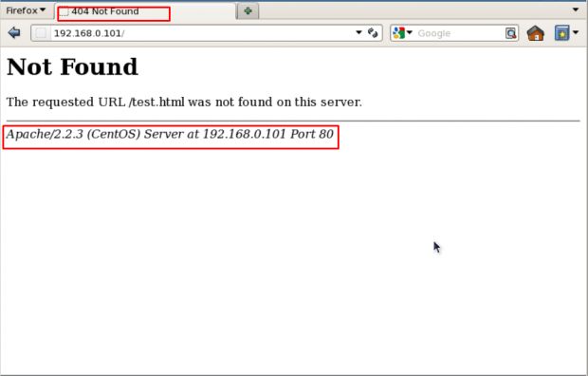
Show Apache Version
In above picture, you can see that Apache is showing its version with the OS installed in your server. This can be a major security threat to your web server as well as your Linux box too. To prevent Apache to not to display these information to the world, we need to make some changes in Apache main configuration file.
Open configuration file with vim editor and search for “ServerSignature“, its by default On. We need to Off these server signature and the second line “ServerTokens Prod” tells Apache to return only Apache as product in the server response header on the every page request, It suppress the OS, major and minor version info.
# vim /etc/httpd/conf/httpd.conf (RHEL/CentOS/Fedora)
# vim /etc/apache2/apache2.conf (Debian/Ubuntu)
ServerSignature Off
ServerTokens Prod
# service httpd restart (RHEL/CentOS/Fedora)
# service apache2 restart (Debian/Ubuntu)
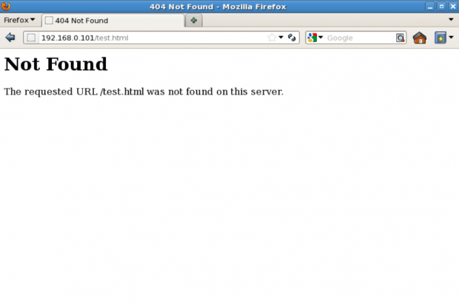
Hide Apache Version

2. Disable Directory Listing
By default Apache list all the content of Document root directory in the absence of index file. Please see the image below.
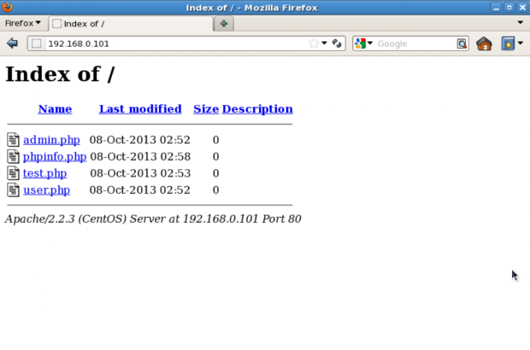
Apache Directory Listing
We can turn off directory listing by using Options directive in configuration file for a specific directory. For that we need to make an entry in httpd.conf or apache2.conf file.
<Directory /var/www/html>
Options -Indexes
</Directory>
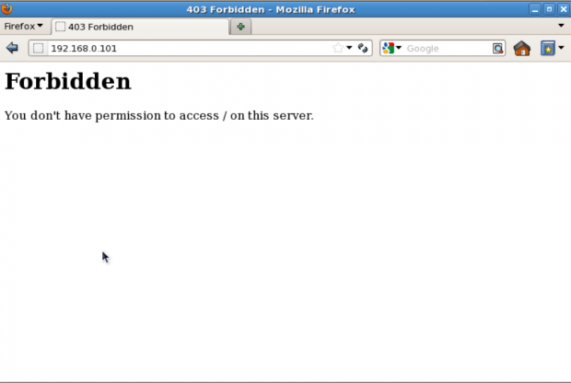
Hide Apache Directory Listing

3. Keep updating Apache Regularly
Apache developer community is continuously working on security issues and releasing its updated version with new security options. So It is always recommended to use the latest version of Apache as your web server.
To check Apache version: You can check your current version with httpd -v command.
# httpd -v
Server version: Apache/2.2.15 (Unix)
Server built: Aug 13 2013 17:29:28
You can update your version with the following command.
# yum update httpd
# apt-get install apache2
It is also recommended to keep your Kernel and OS updated to the latest stable releases if you are not running any specific application which works only on specific OS or Kernel.

4. Disable Unnecessary Modules
It’s always good to minor the chances of being a victim of any web attack. So it’s recommended to disable all those modules that are not in use currently. You can list all the compiled modules of web server, using following command.
# grep LoadModule /etc/httpd/conf/httpd.conf
# have to place corresponding `LoadModule' lines at this location so the
# LoadModule foo_module modules/mod_foo.so
LoadModule auth_basic_module modules/mod_auth_basic.so
LoadModule auth_digest_module modules/mod_auth_digest.so
LoadModule authn_file_module modules/mod_authn_file.so
LoadModule authn_alias_module modules/mod_authn_alias.so
LoadModule authn_anon_module modules/mod_authn_anon.so
LoadModule authn_dbm_module modules/mod_authn_dbm.so
LoadModule authn_default_module modules/mod_authn_default.so
LoadModule authz_host_module modules/mod_authz_host.so
LoadModule authz_user_module modules/mod_authz_user.so
LoadModule authz_owner_module modules/mod_authz_owner.so
LoadModule authz_groupfile_module modules/mod_authz_groupfile.so
LoadModule authz_dbm_module modules/mod_authz_dbm.so
LoadModule authz_default_module modules/mod_authz_default.so
LoadModule ldap_module modules/mod_ldap.so
LoadModule authnz_ldap_module modules/mod_authnz_ldap.so
LoadModule include_module modules/mod_include.so
LoadModule log_config_module modules/mod_log_config.so
LoadModule logio_module modules/mod_logio.so
LoadModule env_module modules/mod_env.so
LoadModule ext_filter_module modules/mod_ext_filter.so
....
Above is the list of modules that are enabled by default but often not needed: mod_imap, mod_include, mod_info, mod_userdir, mod_autoindex. To disable the particular module, you can insert a “#” at the beginning of that line and restart the service.

5. Run Apache as separate User and Group
With a default installation Apache runs its process with user nobody or daemon. For security reasons it is recommended to run Apache in its own non-privileged account. For example: http-web.

Create Apache User and Group
# groupadd http-web
# useradd -d /var/www/ -g http-web -s /bin/nologin http-web
Now you need to tell Apache to run with this new user and to do so, we need to make an entry in /etc/httpd/conf/httpd.conf and restart the service.
Open /etc/httpd/conf/httpd.conf with vim editor and search for keyword “User” and “Group” and there you will need to specify the username and groupname to use.
User http-web
Group http-web

6. Use Allow and Deny to Restrict access to Directories
We can restrict access to directories with “Allow” and “Deny” options in httpd.conf file. Here in this example, we’ll be securing root directory, for that by setting the following in the httpd.conf file.
<Directory />
Options None
Order deny,allow
Deny from all
</Directory>
- Options “None” – This option will not allow users to enable any optional features.
- Order deny, allow – This is the order in which the “Deny” and “Allow” directives will be processed. Here it will “deny” first and “allow” next.
- Deny from all – This will deny request from everybody to the root directory, nobody will be able to access root directory.

7. Use mod_security and mod_evasive Modules to Secure Apache
These two modules “mod_security” and “mod_evasive” are very popular modules of Apache in terms of security.

Mod_security
Where mod_security works as a firewall for our web applications and allows us to monitor traffic on a real time basis. It also helps us to protect our websites or web server from brute force attacks. You can simply install mod_security on your server with the help of your default package installers.

Install mod_security on Ubuntu/Debian
$ sudo apt-get install libapache2-modsecurity
$ sudo a2enmod mod-security
$ sudo /etc/init.d/apache2 force-reload

Install mod_security on RHEL/CentOS/Fedora/
# yum install mod_security
# /etc/init.d/httpd restart

Mod_evasive
mod_evasive works very efficiently, it takes one request to process and processes it very well. It prevents DDOS attacks from doing as much damage. This feature of mod_evasive enables it to handle the HTTP brute force and Dos or DDos attack. This module detects attacks with three methods.
- If so many requests come to a same page in a few times per second.
- If any child process trying to make more than 50 concurrent requests.
- If any IP still trying to make new requests when its temporarily blacklisted.
mod_evasive can be installed directly from the source. Here, we have an Installation and setup guide of these modules which will help you to set up these Apache modules in your Linux box.
- Protect Apache using Mod_Security and Mod_evasive

8. Disable Apache’s following of Symbolic Links
By default Apache follows symlinks, we can turn off this feature with FollowSymLinks with Options directive. And to do so we need to make the following entry in main configuration file.
Options -FollowSymLinks
And, if any particular user or website need FollowSymLinks enable, we can simply write a rule in “.htaccess” file from that website.
# Enable symbolic links
Options +FollowSymLinks
Note: To enable rewrite rules inside “.htaccess” file “AllowOverride All” should be present in the main configuration globally.

9. Turn off Server Side Includes and CGI Execution
We can turn off server side includes (mod_include) and CGI execution if not needed and to do so we need to modify main configuration file.
Options -Includes
Options -ExecCGI
We can do this for a particular directory too with Directory tag. Here In this example, we are turning off Includes and Cgi file executions for “/var/www/html/web1” directory.
<Directory "/var/www/html/web1">
Options -Includes -ExecCGI
</Directory>
Here are some other values with can be turned On or off with Options directive.
- Options All – To enable All options at once. This is the default value, If you don’t want specify any values explicitly in Apache conf file or .htaccess.
- Options IncludesNOEXEC – This option allows server side includes without the execute permission to a command or cgi files.
- Options MultiViews – Allows content negotiated multiviews with mod_negotiation module.
- Options SymLinksIfOwnerMatch – It’s similar to FollowSymLinks. But, this will follow only when the owner is the same between the link and the original directory to which it is linked.

10. Limit Request Size
By default Apache has no limit on the total size of the HTTP request i.e. unlimited and when you allow large requests on a web server its possible that you could be a victim of Denial of service attacks. We can Limit the requests size of an Apache directive “LimitRequestBody” with the directory tag.
You can set the value in bytes from 0 (unlimited) to 2147483647 (2GB) that are allowed in a request body. You can set this limit according to your site needs, Suppose you have a site where you allows uploads and you want to limit the upload size for a particular directory.
Here in this example, user_uploads is a directory which contains files uploaded by users. We are putting a limit of 500K for this.
<Directory "/var/www/myweb1/user_uploads">
LimitRequestBody 512000
</Directory>

11. Protect DDOS attacks and Hardening
Well, it’s true that you cannot completely protect your web site from DDos attacks. Here are some directives which can help you to have a control on it.
- TimeOut : This directive allows you to set the amount of time the server will wait for certain events to complete before it fails. Its default value is 300 secs. It’s good to keep this value low on those sites which are subject to DDOS attacks. This value totally depends on kind of request you are getting on your website. Note: It could pose problems with come CGI scripts.
- MaxClients : This directive allows you to set the limit on connections that will be served simultaneously. Every new connection will be queued up after this limit. It is available with Prefork and Worker both MPM. The default value of it is 256.
- KeepAliveTimeout : Its the amount of time the server will wait for a subsequent request before closing the connection. Default value is 5 secs.
- LimitRequestFields : It helps us to set a limit on the number of HTTP request’s header fields that will be accepted from the clients. Its default value is 100. It is recommended to lower this value if DDos attacks are occurring as a result of so many http request headers.
- LimitRequestFieldSize : It helps us to set a size limit on the HTTP Request header.

12. Enable Apache Logging
Apache allows you to logging independently of your OS logging. It is wise to enable Apache logging, because it provides more information, such as the commands entered by users that have interacted with your Web server.
To do so you need to include the mod_log_config module. There are three main logging-related directives available with Apache.
- TransferLog: Creating a log file.
- LogFormat : Specifying a custom format.
- CustomLog : Creating and formatting a log file.
You can also use them for a particular website it you are doing Virtual hosting and for that you need to specify it in the virtual host section. For example, here is the my website virtual host configuration with logging enabled.
<VirtualHost *:80>
DocumentRoot /var/www/html/example.com/
ServerName www.example.com
DirectoryIndex index.htm index.html index.php
ServerAlias example.com
ErrorDocument 404 /story.php
ErrorLog /var/log/httpd/example.com_error_log
CustomLog /var/log/httpd/example.com_access_log combined
</VirtualHost>

13. Securing Apache with SSL Certificates
Last, but not the least SSL certificates, you can secure your all the communication in an encrypted manner over the Internet with SSL certificate. Suppose you have a website in which people login by proving their Login credentials or you have an E- Commerce website where people provides their bank details or Debit/Credit card details to purchase products, by default your web server send these details in plain – text format but when you use SSL certificates to your websites, Apache sends all this information in encrypted text.
You can purchase SSl certificates from So many different SSL providers like namecheap.com. If you are running a very small web business and do not willing to purchase an SSL certificate you can still assign a Self signed certificate to your website. Apache uses the mod_ssl module to support SSL certificate.
# openssl genrsa -des3 -out example.com.key 1024
# openssl req -new -key example.com.key -out exmaple.csr
# openssl x509 -req -days 365 -in example.com.com.csr -signkey example.com.com.key -out example.com.com.crt
Once your certificate has been created and signed. Now you need to add this in Apache configuration. Open main configuration file with vim editor and add the following lines and restart the service.
<VirtualHost 172.16.25.125:443>
SSLEngine on
SSLCertificateFile /etc/pki/tls/certs/example.com.crt
SSLCertificateKeyFile /etc/pki/tls/certs/example.com.key
SSLCertificateChainFile /etc/pki/tls/certs/sf_bundle.crt
ServerAdmin ravi.saive@example.com
ServerName example.com
DocumentRoot /var/www/html/example/
ErrorLog /var/log/httpd/example.com-error_log
CustomLog /var/log/httpd/example.com-access_log common
</VirtualHost>
Open up your browser, type https://example.com, and you will be able to see the new self-signed certificate.
These are few security tips that you can use to secure your Apache web server installation. For more useful security tips and ideas, see the official online documentation of Apache HTTP Server.

Hardening do Apache
12/03/2008 penguim Leave a comment Go to comments
Dando continuidade ao assunto segurança Web, onde já publique como habilitar o SSL e como fazer o redirect de http para https, agora mostro como fazer um hardening ( endurecimento ) deste grande webserver.
Umas das primeiras coisas a fazer após a instalação do Apache ou de qualquer serviço é limitar as opções de acesso. No caso do Apache faremos isso editando o arquivo /etc/apache2/sites-available/default.
Verifique a seção abaixo:
Options FollowSymLinks
AllowOverride None
Esta seção controla como o Apache tratará o diretório raiz do sistema de arquivos e todos os arquivos contidos nele.
Edite esta seção adcionando as seguintes linhas:
Order Deny,Allow
Deny from all
Options None
AllowOverride None
Isto fará com que o Apache não exiba qualquer arquivo do sistema de arquivos, não permitindo opções especiais (como symlinking, includes, ou scripts cgi), nem que sobreescrevam os arquivos .htaccess nos diretórios. No entanto, uma vez que queremos que o Apache acesse arquivos a partir do diretório /var/www/ , nós precisamos editar a seção abaixo:
Options FollowSymLinks MultiViews
Order allow,deny
Allow from all
Isto permite que o Apache disponibilize páginas contidas em /var/www e removendo Indexes, isto significa que os usuários não serão capazes de acessar o conteúdo dos diretórios na web.
É necessário reiniciar o Apache para que as efetuar as mudanças.
Ocultando a versão do servidor
Agora iremos configurar o Apache para ocultar informações sobre o sistema. Estas informações surgem quando ocorre uma tela de erro. Como o exemplo abaixo:

Error 404
Para ocultar as informações do sistema edite o arquivo /etc/apache2/apache2.conf. Mudando a seguinte linha:
ServerTokens Full
para
ServerTokens Prod
Reinicie o Apache e faça o teste acessando uma página que não existe.
Instalando o Mod_Security
O módulo de segurança, o mod_security, é um módulo do Apache que será instalado para bloquear o monitoramento de requisições e respostas HTTP tanto quanto a negação de pacotes suspeitos.
Inicialmente instale as dependências necessárias
aptitude install libxml2-dev apache2-prefork-dev
Para baixar o source do mod_security clique AQUI, existem também pacotes pré-compilados para várias distros AQUI.
Para baixar o pacote .deb clique AQUI.
Se você optou por baixar o source execute os seguintes passos para compilar o módulo
tar zxvf modsecurity-apache_2.5.7.tar.gz
cd modsecurity-apache_2.5.7/apache2/
./configure && make && make install ( como root! )
Configurando o Apache
Agora acesse o diretório /etc/apache2/mods-available, acesse o arquivo modsecurity2.load e adicione as seguintes linhas:
LoadFile /usr/lib/libxml2.so
LoadModule security2_module /usr/lib/apache2/modules/mod_security2.so
Agora vá para um diretório acima, no caso o mods-enabled e crie um link simbólico para os arquivo editado anteriormente e para o arquivo mod_unique_id:
cd ../mods-enabled
ln -s ../mods-available/modsecurity2.load
ln -s ../mods-available/unique_id.load
Após reiniciar o Apache, verifique o aquivo de log que está em /var/log/apache2/error.log. Deverá existir a seguinte linha:
[Wed Dec 03 16:54:25 2008] [notice] ModSecurity for Apache/2.5.2 (http://www.modsecurity.org/) configured.
Configurando o Mod_security
Primeiro, as regras necessárias para inciar o funcionamento deste módulo encontra-se no diretório /modsecurity-apache_2.5.7/rules, copie estas regras para o diretório /var/lib/modsecurity/
cp modsecurity_crs_* /var/lib/modsecurity/
Informe ao Apache onde encontram-se a regras criando o arquivo /etc/apache2/conf.d/modsecurity2.conf e adicionando as seguintes linhas:
Include /var/lib/modsecurity/*.conf
Reinicie o Apache para efetivar as mudanças
Testando o Mod_security
Agora que o módulo já está configurado e rodando podemos realizar um teste simples usando o wget:
wget -O – -U “ngsecurity analyzer” http://
Se o mod_security estiver funcionando, será informado o erro 404:
alexos@cypher:~$ wget -O – -U “ngsecurity analyzer” http://
–19:13:17– http://
=> `-‘
Resolving meu_webtestserver… X.X.X.X
Connecting to meu_webtestserver|X.X.X.X|:80… connected.
HTTP request sent, awaiting response… 404 Not Found
19:13:17 ERROR 404: Not Found.
No servidor web execute o comando abaixo
tail /var/log/apache2/debug.log
ou
tail /var/log/apache2/audit.log
Vejam o que apareceu para mim!
[03/Dec/2008:17:18:17 –0500] [matrix/sid#855d8f0][rid#87357f8][/][1]
Access denied with code 404 (phase 2). Pattern match “(?:\b(?:m(?:ozilla\/4\.0 \
(compatible\)|etis)|ngsecurity analyzer|pmafind)\b|n(?:-stealth|sauditor|
essus|ikto)|b(?:lack ?widow|rutus|ilbo)|(?:jaascoi|paro)s|webinspect|\.nasl)” at
REQUEST_HEADERS:User-Agent. [file “/var/lib/modsecurity/modsecurity_crs_35_bad_robots.conf”]
[line “19”] [id “990002”] [msg “Request Indicates a Security Scanner Scanned the Site”]
[severity “CRITICAL”] [tag “AUTOMATION/SECURITY_SCANNER”]
Porque surgiu na expressão regular acima o “ngsecurity analyzer”, a requisição para o arquivo foi negada, mostrando que o mod_security está funcionando.
Então é isso moçada! Num próximo artigo falarei sobre Hardening do S.O.
* Hardening – É um processo de mapeamento das ameaças, mitigação dos riscos e execução das atividades corretivas – com foco na infra-estrutura e objetivo principal de torná-la preparada para enfrentar tentativas de ataque. ( Wikipedia )
Fonte:
Debian Clusters

Apache Web Server Hardening and Security Guide

A practical guide to secure and harden Apache Web Server.

1. Introduction
The Web Server is a crucial part of web-based applications. Apache Web Server is often placed at the edge of the network hence it becomes one of the most vulnerable services to attack.
Having default configuration supply much sensitive information which may help hacker to prepare for an attack the web server.
The majority of web application attacks are through XSS, Info Leakage, Session Management and PHP Injection attacks which are due to weak programming code and failure to sanitize web application infrastructure.
According to the security vendor Acunetix, 84% of tested applications have one or more vulnerabilities.
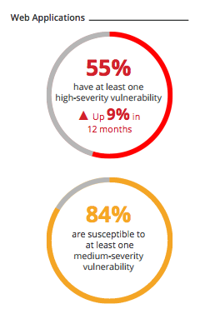
This practical guide provides you the necessary skill set to secure Apache Web Server.
In this course, we will talk about how to Harden & Secure Apache Web Server on Unix platform.
Following are tested on Apache 2.4.x version.
- This assumes you have installed Apache on UNIX platform. If not, you can go through Installation guide.
- We will call Apache installation directory /opt/apache as $Web_Server throughout this guide.
- You are advised to take a backup of existing configuration file before any modification.
Contents
- 1. Introduction
  - 1.1 Audience
  - 1.1 Notes
- 2. Information Leakage
  - 2.1 Remove Server Version Banner
  - 2.2 Disable directory browser listing
  - 2.3 Etag
- 3. Authorization
  - 3.1 Run Apache from non-privileged account
  - 3.2 Protect binary and configuration directory permission
  - 3.3 System Settings Protection
  - 3.4 HTTP Request Methods
- 4. Web Application Security
  - 4.1 Cookies
  - 4.1.1 Disable Trace HTTP Request
  - 4.1.2 Set cookie with HttpOnly and Secure flag
  - 4.2 Clickjacking Attack
  - 4.3 Server Side Include
  - 4.4 X-XSS Protection
  - 4.5 Disable HTTP 1.0 Protocol
  - 4.6 Timeout value configuration
- 5. SSL
  - 5.1 SSL Key
  - 5.2 SSL Cipher
  - 5.3 Disable SSL v2 & v3
- 6. Mod Security
  - 6.1 Download & Installation
  - 6.2 Configuration
  - 6.3 Getting Started
  - 6.3.1 Logging
  - 6.3.2 Enable Rule Engine
  - 6.3.3 Common Attack Type Protection
  - 6.3.4 Change Server Banner
- 7. General Configuration
  - 7.1 Configure Listen
  - 7.2 Access Logging
  - 7.3 Disable Loading unwanted modules

1.1 Audience
This is designed for Middleware Administrator, Application Support, System Analyst, or anyone working or eager to learn Hardening & Security guidelines.
Fair knowledge of Apache Web Server & UNIX command is mandatory.

Bonus: Click here to download this guide in PDF format.

1.1 Notes
We require some tool to examine HTTP Headers for some of the implementation verification. There are two ways to do this.
- Use browser inbuilt developer tools to inspect the HTTP headers. Usually, it’s under Network tab
- Use online HTTP response header checker tool

2. Information Leakage
In default Apache configuration you would have much sensitive information disclosures, which can be used to prepare for an attack.
It’s one of the most critical tasks for an administrator to understand and secure them.

2.1 Remove Server Version Banner
I would say this is one of the first things to consider, as you don’t want to expose what web server version you are using. Exposing version means you are helping hacker to speedy the reconnaissance process.
The default configuration will expose Apache Version and OS type as shown below.
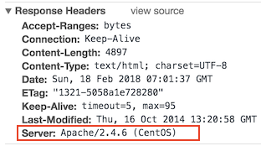
Implementation
- Go to $Web_Server/conf folder
- Modify httpd.conf by using vi editor
- Add the following directive and save the httpd.conf
ServerTokens Prod
ServerSignature Off
- Restart apache
ServerSignature will remove the version information from the page generated by apache web server.
ServerTokens will change Header to production only, i.e. Apache
Verification
As you can see below, version & OS information is gone.
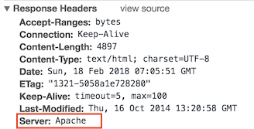

2.2 Disable directory browser listing
Disable directory listing in a browser, so the visitor doesn’t see what all file and folders you have under root or subdirectory.
Let’s test how does it look like in default settings.
- Go to $Web_Server/htdocs directory
- Create a folder and few files inside that
# mkdir test
# touch hi
# touch hello
Now, let’s try to access Apache by http://localhost/test
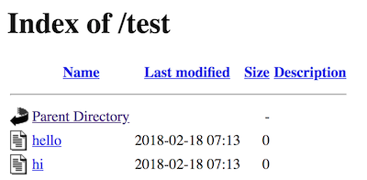
As you could see it reveals what all file/folders you have which are probably you don’t want to expose.
Implementation
- Go to $Web_Server/conf directory
- Open httpd.conf using vi
- Search for Directory and change Options directive to None or –Indexes
<Directory /opt/apache/htdocs>
Options -Indexes
</Directory>
(or)
<Directory /opt/apache/htdocs>
Options None
</Directory>
- Restart Apache
Note: if you have multiple Directory directives in your environment, you should consider doing the same for all.
Verification
Now, let’s try to access Apache by http://localhost/test
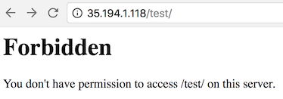
As you could see, it displays a forbidden error instead of showing test folder listing.

2.3 Etag
It allows remote attackers to obtain sensitive information like inode number, multipart MIME boundary, and child process through Etag header.
To prevent this vulnerability, let’s implement it as below. This is required to fix for PCI compliance.
Implementation
- Go to $Web_Server/conf directory
- Add the following directive and save the httpd.conf
FileETag None
- Restart apache

3. Authorization

3.1 Run Apache from non-privileged account
Default apache configuration is to run as nobody or daemon. It’s good to use a separate non-privileged user for Apache.
The idea here is to protect other services running in case of any security hole.
Implementation
- Create a user and group called apache
# groupadd apache
# useradd –G apache apache
- Change apache installation directory ownership to newly created non-privileged user
# chown –R apache:apache /opt/apache
- Go to $Web_Server/conf
- Modify httpd.conf using vi
- Search for User & Group Directive and change as non-privileged account apache
User apache
Group apache
- Save the httpd.conf
- Restart Apache
Verification
grep for running http process and ensure it’s running with apache user
# ps –ef |grep http
You should see one process is running with root. That’s because Apache is listening on port 80 and it has to be started with root.

3.2 Protect binary and configuration directory permission
By default, permission for binary and configuration is 755 that mean any user on a server can view the configuration. You can disallow another user to get into conf and bin folder.
Implementation
- Go to $Web_Server directory
- Change permission of bin and conf folder
# chmod –R 750 bin conf

3.3 System Settings Protection
In a default installation, users can override apache configuration using .htaccess. if you want to stop users changing your apache server settings, you can add AllowOverride to None as shown below.
This must be done at the root level.
Implementation
- Go to $Web_Server/conf directory
- Open httpd.conf using vi
- Search for Directory at root level
<Directory />
Options -Indexes
AllowOverride None
</Directory>
- Save the httpd.conf
- Restart Apache

3.4 HTTP Request Methods
HTTP 1.1 protocol support many request methods which may not be required and some of them are having potential risk.
Typically you may just need GET, HEAD, POST request methods in a web application, which can be configured in the respective Directory directive.
Default apache configuration support OPTIONS, GET, HEAD, POST, PUT, DELETE, TRACE, CONNECT method in HTTP 1.1 protocol.
Implementation
- Go to $Web_Server/conf directory
- Open httpd.conf using vi
- Search for Directory and add following
<LimitExcept GET POST HEAD>
deny from all
</LimitExcept>
- Restart Apache

4. Web Application Security
Apache web server misconfiguration or not hardened properly can exploit web application. It’s critical to harden your web server configuration.

4.1 Cookies

4.1.1 Disable Trace HTTP Request
By default Trace method is enabled in Apache web server.
Having this enabled can allow Cross Site Tracing attack and potentially giving an option to a hacker to steal cookie information. Let’s see how it looks like in default configuration.
- Do a telnet web server IP with listening port
- Make a TRACE request as shown below
#telnet localhost 80
Trying 127.0.0.1...
Connected to localhost.
Escape character is '^]'.
TRACE / HTTP/1.1 Host: test
HTTP/1.1 200 OK
Date: Sat, 31 Aug 2013 02:13:24 GMT
Server: Apache
Transfer-Encoding: chunked
Content-Type: message/http 20
TRACE / HTTP/1.1
Host: test
0
Connection closed by foreign host.#
As you could see in above TRACE request, it has responded my query. Let’s disable it and test it.
Implementation
- Go to $Web_Server/conf directory
- Add the following directive and save the httpd.conf
TraceEnable off
- Restart apache
Verification
- Do a telnet web server IP with listen port and make a TRACE request as shown below
#telnet localhost 80
Trying 127.0.0.1...
Connected to localhost.
Escape character is '^]'.
TRACE / HTTP/1.1 Host: test
HTTP/1.1 405 Method Not Allowed
Date: Sat, 31 Aug 2013 02:18:27 GMT
Server: Apache Allow:Content-Length: 223Content-Type: text/html; charset=iso-8859-1 <!DOCTYPE HTML PUBLIC "-//IETF//DTD HTML 2.0//EN"> <html><head>
<title>405 Method Not Allowed</title> </head><body>
<h1>Method Not Allowed</h1>
<p>The requested method TRACE is not allowed for the URL /.</p> </body></html>
Connection closed by foreign host.#
As you could see in above TRACE request, it has blocked my request with HTTP 405 Method Not Allowed.
Now, this web server doesn’t allow TRACE request and help in blocking Cross Site Tracing attack.

4.1.2 Set cookie with HttpOnly and Secure flag
You can mitigate most of the common Cross Site Scripting attack using HttpOnly and Secure flag in a cookie. Without having HttpOnly and Secure, it is possible to steal or manipulate web application session and cookies and it’s dangerous.
Implementation
- Ensure mod_headers.so is enabled in your httpd.conf
- Go to $Web_Server/conf directory
- Add the following directive and save the httpd.conf
Header edit Set-Cookie ^(.*)$ $1;HttpOnly;Secure
- Restart apache

4.2 Clickjacking Attack
Clickjacking is well-known web application vulnerabilities.
Implementation:
- Ensure mod_headers.so is enabled in your httpd.conf
- Go to $Web_Server/conf directory
- Add the following directive and save the httpd.conf
Header always append X-Frame-Options SAMEORIGIN
- Restart apache
Verification
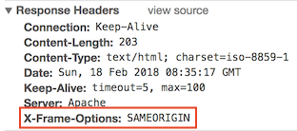
X-Frame-Options also support two more options which I explained here.

4.3 Server Side Include
Server Side Include (SSI) has a risk of increasing the load on the server. If you have shared the environment and heavy traffic web applications you should consider disabling SSI by adding Includes in Options directive.
SSI attack allows the exploitation of a web application by injecting scripts in HTML pages or executing codes remotely.
Implementation
- Go to $Web_Server/conf directory
- Open httpd.conf using vi
- Search for Directory and add Includes in Options directive
<Directory /opt/apache/htdocs>
Options –Indexes -Includes
Order allow,denyAllow from all
</Directory>
- Restart Apache
Note: if you have multiple Directory directives in your environment, you should consider doing the same for all.

4.4 X-XSS Protection
Cross Site Scripting (XSS) protection can be bypassed in many browsers. You can apply this protection for a web application if it was disabled by the user. This is used by a majority of giant web companies like Facebook, Twitter, Google, etc.
Implementation
- Go to $Web_Server/conf directory
- Open httpd.conf using vi and add following Header directive
Header set X-XSS-Protection "1; mode=block"
- Restart Apache
Verification
As you can see, XSS-Protection is the injected in the response header.
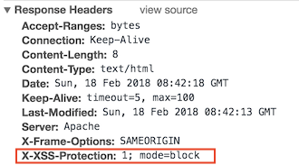

4.5 Disable HTTP 1.0 Protocol
When we talk about security, we should protect as much we can. So why do we use older HTTP version of the protocol, let’s disable them as well?
HTTP 1.0 has security weakness related to session hijacking. We can disable this by using the mod_rewrite module.
Implementation
- Ensure to load mod_rewrite module in httpd.conf file
- Enable RewriteEngine directive as following and add Rewrite condition to allow only HTTP 1.1
RewriteEngine On
RewriteCond %{THE_REQUEST} !HTTP/1.1$
RewriteRule .* - [F]

4.6 Timeout value configuration
By default Apache time-out value is 300 seconds, which can be a victim of Slow Loris attack and DoS. To mitigate this you can lower the timeout value to maybe 60 seconds.
Implementation
- Go to $Web_Server/conf directory
- Open httpd.conf using vi
- Add following in httpd.conf
Timeout 60

5. SSL
Having SSL is an additional layer of security you are adding into Web Application. However, default SSL configuration leads to certain vulnerabilities and you should consider tweaking those configurations.

5.1 SSL Key
Breaching SSL key is hard, but not impossible. It’s just matter of computational power and time.
As you might know, using a 2009-era PC cracking away for around 73 days you can reverse engineer a 512-bit key.
So the higher key length you have, the more complicated it becomes to break SSL key. The majority of giant Web Companies use 2048 bit key, as below so why don’t we?
- Outlook.com
- Microsoft.com
- Live.com
- Skype.com
- Apple.com
- Yahoo.com
- Bing.com
- Hotmail.com
- Twitter.com
Implementation
- You can use openssl to generate CSR with 2048 bit as below.
openssl req -out geekflare.csr -newkey rsa:2048 -nodes -keyout geekflare.key
It will generate a CSR which you will need to send to a certificate authority to sign it. Once you receive the signed certificate file, you can add them in httpd-ssl.conf file
SSLCertificateFile #Certificate signed by authority
SSLCertificateChainFile #Certificate signer given by authority
SSLCertificateKeyFile #Key file which you generated above
- Restart Apache web server and try to access the URL with https

5.2 SSL Cipher
SSL Cipher is an encryption algorithm, which is used as a key between two computers over the Internet. Data encryption is the process of converting plain text into secret ciphered codes.
It’s based on your web server SSL Cipher configuration the data encryption will take place.
So it’s important to configure SSL Cipher, which is stronger and not vulnerable.
Implementation:
- Go to $Web_Server/conf/extra folder
- Modify SSLCipherSuite directive in httpd-ssl.conf as below to accept only higher encryption algorithms
SSLCipherSuite HIGH:!MEDIUM:!aNULL:!MD5:!RC4
- Save the configuration file and restart apache server
Note: if you have many weak ciphers in your SSL auditing report, you can quickly reject them adding ! at beginning.

5.3 Disable SSL v2 & v3
SSL v2 & v3 has many security flaws, and if you are working towards penetration test or PCI compliance, then you are expected to close security finding to disable SSL v2/v3.
Any SSL v2/v3 communication may be vulnerable to a Man-in-The-Middle attack that could allow data tampering or disclosure.
Let’s implement apache web server to accept only latest TLS and reject SSL v2/v3 connection request.
Implementation
- Go to $Web_Server/conf/extra folder
- Modify SSLProtocol directive in httpd-ssl.conf as below to accept only TLS 1.0+
SSLProtocol –ALL +TLSv1 +TLSv1.1 +TLSv1.2
Once you are done with SSL configuration, it’s a good idea to test your web application with online SSL/TLS Certificate tool to find any configuration error.

6. Mod Security
Mod Security is an open-source Web Application Firewall, which you can use with Apache.
It comes as a module which you have to compile and install. If you can’t afford commercial web application firewall, this would be a good choice to go for it. Mod Security says:
In order to provide generic web applications protection, the Core Rules use the following techniques:
- HTTP Protection – detecting violations of the HTTP protocol and a locally defined usage policy
- Real-time Blacklist Lookups – utilizes 3rd Party IP Reputation
- Web-based Malware Detection – identifies malicious web content by check against the Google Safe Browsing API.
- HTTP Denial of Service Protections – defense against HTTP Flooding and Slow HTTP DoS Attacks.
- Common Web Attacks Protection – detecting common web application security attack
- Automation Detection – Detecting bots, crawlers, scanners and another malicious surface activity
- Integration with AV Scanning for File Uploads – identifies malicious files uploaded through the web application.
- Tracking Sensitive Data – Tracks Credit Card usage and blocks leakages.
- Trojan Protection – Detecting access to Trojans horses.
- Identification of Application Defects – alerts on application misconfigurations.
- Error Detection and Hiding – Disguising error messages sent by the server.

6.1 Download & Installation
Following prerequisites must be installed on the server where you wish to use Mod Security with Apache. If anyone of these doesn’t exist then Mod Security compilation will fail. You may use yum install on Linux or Centos to install these packages.
- apache 2.x or higher
- libpcre package
- libxml2 package
- liblua package
- libcurl package
- libapr and libapr-util package
- mod_unique_id module bundled with Apache web server
Now, let’s download the latest stable version of Mod Security 2.7.5 from http://www.modsecurity.org/download/
- Transfer downloaded file to /opt/apache
- Extract modsecurity-apache_2.7.5.tar.gz
# gunzip –c modsecurity-apache_2.7.5.tar.gz | tar xvf –
- Go to extracted folder modsecurity-apache_2.7.5
# cd modsecurity-apache_2.7.5
- Run the configure script including apxs path to existing Apache
# ./configure –with-apxs=/opt/apache/bin/apxs
- Compile & install with make script
# make
# make install
- Once installation is done, you would see mod_security2.so in modules folder under /opt/apache
Now this concludes, you have installed Mod Security module in existing Apache web server.

6.2 Configuration
In order to use Mod security feature with Apache, we have to load mod security module in httpd.conf. The mod_unique_id module is pre-requisite for Mod Security.
This module provides an environment variable with a unique identifier for each request, which is tracked and used by Mod Security.
- Add following a line to load module for Mod Security in httpd.conf and save the configuration file
LoadModule unique_id_module modules/mod_unique_id.so
LoadModule security2_module modules/mod_security2.so
- Restart apache web server
Mod Security is now installed!
Next thing you have to do is to install Mod Security core rule to take full advantage of its feature.
Latest Core Rule can be downloaded from following a link, which is free. https://github.com/SpiderLabs/owasp-modsecurity-crs/zipball/master
- Copy downloaded core rule zip to /opt/apache/conf folder
- Unzip core rule file
- You may wish to rename the folder to something short and easy to remember. In this example, I will rename to crs.
- Go to crs folder and rename modsecurity_crs10_setup.conf.example to modsecurity_crs10_setup.conf
Now, let’s enable these rules to get it working with Apache web server.
- Add following in httpd.conf
<IfModule security2_module>
Include conf/crs/modsecurity_crs_10_setup.confInclude conf/crs/base_rules/*.conf
</IfModule>
In above configuration, we are loading Mod Security main configuration file modsecurity_crs_10_setup.conf and base rules base_rules/*.conf provided by Mod Security Core Rules to protect web applications.
- Restart apache web server
You have successfully configured Mod Security with Apache!
Well done. Now, Apache Web server is protected by Mod Security web application firewall.

6.3 Getting Started
Let’s get it started with some of the critical configurations in Mod Security to harden & secure web applications.
In this section, we will do all configuration modification in /opt/apache/conf/crs/modsecurity_crs_10_setup.conf.
We will refer /opt/apache/conf/crs/modsecurity_crs_10_setup.conf as setup.conf in this section for example purpose.
It’s important to understand what are the OWASP rules are provided for free. There are two types of rules provided by OWASP.
Base Rules – these rules are heavily tested, and probably false alarm ratio is less.
Experimental Rules – these rules are for an experimental purpose, and you may have the high false alarm. It’s important to configure, test and implement in UAT before using these in a production environment.
Optional Rules – these optional rules may not be suitable for the entire environment. Based on your requirement you may use them.
If you are looking for CSRF, User tracking, Session hijacking, etc. protection then you may consider using optional rules. We have the base, optional and experimental rules after extracting the downloaded crs zip file from OWASP download page.
These rules configuration file is available in crs/base_rules, crs/optional_rules and crs/experimental_rules folder. Let’s get familiar with some of the base rules.
- modsecurity_crs_20_protocol_violations.conf:This rule is protecting from Protocol vulnerabilities like response splitting, request smuggling, using non-allowed protocol (HTTP 1.0).
- modsecurity_crs_21_protocol_anomalies.conf:This is to protect from a request, which is missing with Host, Accept, User-Agent in the header.
- modsecurity_crs_23_request_limits.conf:This rule has the dependency on application specific like request size, upload size, a length of a parameter, etc.
- modsecurity_crs_30_http_policy.conf:This is to configure and protect allowed or disallowed method like CONNECT, TRACE, PUT, DELETE, etc.
- modsecurity_crs_35_bad_robots.conf:Detect malicious robots
- modsecurity_crs_40_generic_attacks.conf:This is to protect from OS command injection, remote file inclusion, etc.
- modsecurity_crs_41_sql_injection_attacks.conf:This rule to protect SQL and blind SQL inject request.
- modsecurity_crs_41_xss_attacks.conf:Protection from Cross-Site Scripting request.
- modsecurity_crs_42_tight_security.conf:Directory traversal detection and protection.
- modsecurity_crs_45_trojans.conf:This rule to detect generic file management output, uploading of HTTP backdoor page, known signature.
- modsecurity_crs_47_common_exceptions.conf:This is used as an exception mechanism to remove common false positives that may be encountered suck as Apache internal dummy connection, SSL pinger, etc.

6.3.1 Logging
Logging is one of the first things to configure so you can have logs created for what Mod Security is doing. There are two types of logging available; Debug & Audit log.
Debug Log: this is to duplicate the Apache error, warning and notice messages from the error log.
Audit Log: this is to write the transaction logs that are marked by Mod Security rule Mod Security gives you the flexibility to configure Audit, Debug or both logging. By default configuration will write both logs. However, you can change based on your requirement. The log is controlled in SecDefaultAction directive. Let’s look at default logging configuration in setup.conf
SecDefaultAction “phase:1,deny,log”
To log Debug, Audit log – use “log” To log only audit log – use “nolog,auditlog” To log only debug log – use “log,noauditlog” You can specify the Audit Log location to be stored which is controlled by SecAuditLog directive.
Let’s write audit log into /opt/apache/logs/modsec_audit.log by adding as shown below.
Implementation
- Add SecAuditLog directive in setup.conf and restart Apache Web Server
SecAuditLog /opt/apache/logs/modsec_audit.log
- After the restart, you should see modsec_audit.log getting generated

6.3.2 Enable Rule Engine
By default Engine Rule is Off that means if you don’t enable Rule Engine you are not utilizing all the advantages of Mod Security.
Rule Engine enabling or disabling is controlled by SecRuleEngine directive.
Implementation
- Add SecRuleEngine directive in setup.conf and restart Apache Web Server
SecRuleEngine On
There are three values for SecRuleEngine:
- On – to enable Rule Engine
- Off – to disable Rule Engine
- DetectionOnly – enable Rule Engine but never executes any actions like block, deny, drop, allow, proxy or redirect
Once Rule Engine is on – Mod Security is ready to protect with some of the common attack types.

6.3.3 Common Attack Type Protection
Now web server is ready to protect with common attack types like XSS, SQL Injection, Protocol Violation, etc. as we have installed Core Rule and turned on Rule Engine. Let’s test few of them.
XSS Attack:-
- Open Firefox and access your application and put <script> tag at the end or URL
- Monitor the modsec_audit.log in apache/logs folder
You will notice Mod Security blocks request as it contains <script> tag which is the root of XSS attack.
Directory Traversal Attack:- Directory traversal attacks can create a lot of damage by taking advantage of this vulnerabilities and access system related file. Ex – /etc/passwd, .htaccess, etc.
- Open Firefox and access your application with directory traversal
- Monitor the modsec_audit.log in apache/logs folder
http://localhost/?../.../boot
- You will notice Mod Security blocks request as it contains directory traversal.

6.3.4 Change Server Banner
Earlier in this guide, you learned how to remove Apache and OS type, version help of ServerTokens directive.
Let’s go one step ahead, how about keeping server name whatever you wish? It’s possible with SecServerSignature directive in Mod Security. You see it’s interesting.
Note: to use Mod Security to manipulate Server Banner from a header, you must set ServerTokesn to Full in httpd.conf of Apache web server.
Implementation
- Add SecServerSignature directive with your desired server name in setup.conf and restart Apache Web Server
SecServerSignature YourServerName
Ex:
[/opt/apache/conf/crs] #grep SecServer modsecurity_crs_10_setup.conf
SecServerSignature geekflare.com
[/opt/apache/conf/crs] #

7. General Configuration
We will talk about some of the general configuration as best practice.

7.1 Configure Listen
When you have multiple interface and IP’s on a single server, it’s recommended to have Listen directive configured with absolute IP and Port number.
When you leave apache configuration to Listen on all IP’s with some port number, it may create the problem in forwarding HTTP request to some other web server. This is quite common in the shared environment.
Implementation
- Configure Listen directive in httpd.conf with absolute IP and port as shown example below
Listen 10.10.10.1:80

7.2 Access Logging
It’s essential to configure access log properly in your web server. Some of the important parameter to capture in the log would be the time taken to serve the request, SESSION ID.
By default, Apache is not configured to capture these data. You got to configure them manually as follows.
Implementation
- To capture time taken to serve the request and SESSION ID in access log
- Add %T & %sessionID in httpd.conf under LogFormat directive
LogFormat "%h %l %u %t "%{sessionID}C" "%r" %>s %b %T" common
You can refer http://httpd.apache.org/docs/2.2/mod/mod_log_config.html for a complete list of parameter supported in LogFormat directive in Apache Web Server.

7.3 Disable Loading unwanted modules
If you have compiled and installed with all modules, then there are high chances you will have many modules loaded in Apache, which may not be required.
Best practice is to configure Apache with required modules in your web applications. Following modules have security concerns, and you might be interested in disabling in httpd.conf of Apache Web Server.
WebDAV (Web-based Distributed Authoring and Versioning) This module allows remote clients to manipulate files on the server and subject to various denial-of-service attacks. To disable comment following in httpd.conf
#LoadModule dav_module modules/mod_dav.so
#LoadModule dav_fs_module modules/mod_dav_fs.so
#Include conf/extra/httpd-dav.conf
Info Module The mod_info module can leak sensitive information using .htaccess once this module is loaded. To disable comment following in httpd.conf
#LoadModule info_module modules/mod_info.so
Reference: This wouldn’t be possible without guidance from the following link:
- http://httpd.apache.org/docs/2.4/
- http://www.modsecurity.org/documentation/
- https://www.owasp.org/index.php/Category:OWASP_ModSecurity_Core_Rule_Set_Project
So that was some of the best practices you can use to secure your Apache web server.
If you are new to Apache HTTP, then I would recommend taking Apache HTTP administration course.
https://geekflare.com/apache-web-server-hardening-security/

Apache server security: 10 tips to secure installation
Posted on by Glenn Darmanin
Apache is one of the most popular web servers. As of September 2014, it is used to host 55.7% of the top 1 million websites. It is also often described as one of the most secure web servers. In this article, I shall describe some configuration changes that will harden your Apache’s configuration.

Ensure that Apache server-info is disabled
If the <Location /server-info> directive in the httpd.conf configuration file is enabled it would display information about the Apache configuration when the /server-info page is accessed from http://www.example.com/server-info. This could potentially include sensitive information about server settings such as the server version, system paths, database names, library information and so on. In the underlying screenshot we can see that the Apache /server-info lists the server version, which also includes the OpenSSL version. From this information an attacker could deduce that this server is making use of a version of OpenSSL which is vulnerable to the Heartbleed Bug and thus could now also exploit this vulnerability.
https://www.acunetix.com/wp-content/uploads/2014/10/Server_Info.png
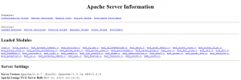
Figure 1 – Part of Apache /server-info which clearly lists the server version, OpenSSL version, and PHP version, among other information.
This can be disabled by either commenting out the entire mod_info module from the httpd.conf Apache configuration file as per below:
#LoadModule info_module modules/mod_info.so
Or by commenting out the <Location /server-status> directive from the httpd.conf Apache configuration file as is shown below:
#<Location /server-status>
# SetHandler server-status
# Order deny,allow
# Deny from all
# Allow from .your_domain.com
#</Location>

Ensure that Apache server-status is disabled
When enabled, the <Location /server-status> directive lists information about the server’s performance, such as server uptime, server load, current HTTP requests, and client IP addresses. An attacker may make use of this information to craft an attack against the web server.
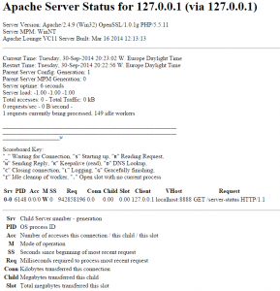
Figure 2 – The server-status page, accessible from http://your.host.example.com/server-status, showing various information with regards to the server’s performance

Disable the ServerSignature directive
The ServerSignature directive endows server-generated documents with a footer which includes information about your Apache configuration such as the version of Apache and the OS server name. In order to restrict Apache from displaying this sensitive information the ServerSginature directive in your Apache configuration would need to be disabled as shown below:
ServerSignature Off
Figure 3 – Leaving the Apache ServerSignature directive enabled displays a footer with information about your Apache configuration

Set the ServerTokens directive to Prod
The ServerTokens directive controls what information about the server is sent back in the Server response header field. A number of syntaxes can be used with this directive, as listed in the Apache ServerTokens documentation. The ServerTokens directive should be set to Prod in order to instruct Apache to return only ‘Apache’ in the server response headers. This can be done by including the below directive in your httpd.conf Apache configuration file:
ServerTokens Prod

Disable Directory Listing
Directory listing displays a list of the directory contents which would include all the files from that website. If this is enabled, an attacker can simply discover and view any file. This could potentially lead to the attacker decompiling and reverse engineering an application in order to obtain the application’s source code. The attacker can then analyze the source code for possible security flaws or to obtain more information about an application, such as database connection strings, passwords to other systems etc. Directory listing can be disabled by setting the Options directive in the Apache httpd.conf file:
<Directory /your/website/directory>
Options -Indexes
</Directory>
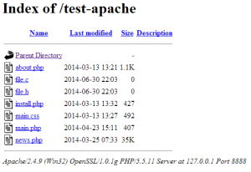
Figure 4 – Apache directory listing

Enable only the modules that are required
A default installation of Apache may include a number of pre-installed and enabled modules which you might not need. To add insult to injury, some web server admins tend to take the path of least resistance and enable all the remaining modules in httpd.conf, so as to ensure that everything works without a hitch. This, however, also opens up the web server to any security issues that might exist, or be discovered in the future for the modules that are enabled.
The Apache module documentation lists and explains all the modules available within Apache. Research the modules that you have enabled, and ensure that these are really required for the functionality of the website. Unnecessary modules should be disabled by adding a # character in front of the LoadModule line.
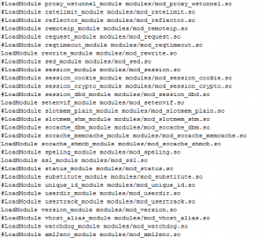
Figure 5 – A section of the httpd.conf Apache configuration file showing the majority of modules being disabled including the mod_status.so module

Make use of an appropriate user and group
By default Apache will run under the daemon user and group, however it is best practice to run Apache in a non-privileged account. Furthermore, if two processes, such as Apache and MySQL for example, are running under the same user and group, issues in one process might lead to exploits in the other process. To change Apache’s user and group the User and Group directives in the Apache httpd.conf configuration file need to be changed:
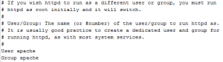
Figure 6 – An excerpt of the httpd.conf configuration file showing the user and group Apache runs on as ‘apache’

Restrict unwanted services
You may want to disable certain services, such as CGI execution and symbolic links, if these are not needed. You can disable these services with the Options directive from the httpd.conf configuration file and may also disable these services for a particular directory only. The below example shows us what you need to include in your httpd.conf configuration file to disable CGI execution, symbolic links, and server side includes.
<Directory /your/website/directory>
Options -ExecCGI -FollowSymLinks -Includes
</Directory>

Make use of ModSecurity
mod_security is an open-source module that works as a web application firewall. Different functionalities include filtering, server identity masking, and null byte attack prevention. Real-time traffic monitoring is also allowed through this module. Therefore it is recommended to follow the ModSecurity manual to install the mod_security module in order to empower your security options.

Updates
You should always keep up to date with the latest versions of Apache, as new updates will contain new fixes and patches that will address past security issues and also introduce new security measures. The best way to keep up to date about new versions of Apache is to subscribe to the Apache Server Announcements mailing list at announce-subscribe@httpd.apache.org.

Enable logging
Apache logging provides detailed information about client requests made on your web server, hence enabling such logging will prove useful when investigating the cause of particular issues. In order to enable logging the mod_log_config module needs to be included from the Apache httpd.conf file. This module provides the TransferLog, LogFormat, and CustomLog directives which are respectively used to create a log file, specify a custom format, and creating and formatting a log file in one step. As seen below, the LogFormat directive is used to specify a custom logging format – in this case the referrer and browser of each request are logged along with the default logging parameters. Then, the CustomLog directive will be used to instruct Apache to use this logging format.
LogFormat "%h %l %u %t \"%r\" %>s %b \"%{Referer}i\" \"%{User-Agent}i\"" detailed
CustomLog logs/access.log detailed

How To Install Apache, MySQL, PHP stack on FreeBSD Unix Server
in Categories Apache, FreeBSD, MySQL, PHP, UNIX last updated January 11, 2015
I‘m a new FreeBSD Unix system users. How can I setup and install Apache, MySQL, PHP stack on a FreeBSD 10 based Unix server?
FAMP stack is nothing but group of source software to run php based apps. Our sample setup includes:
- FreeBSD 10.1-RELEASE amd64
- Apache v2.4
- PHP v5.6
- MySQL v5.6
This tutorial explains how to install and configure FAMP stack.

Update your ports
Like always make sure everything is up to date before starting. I like to do:
# portsnap fetch update && portupgrade -a
Sample outputs:
Looking up portsnap.FreeBSD.org mirrors... 7 mirrors found.
Fetching public key from your-org.portsnap.freebsd.org... done.
Fetching snapshot tag from your-org.portsnap.freebsd.org... done.
Fetching snapshot metadata... done.
Fetching snapshot generated at Fri Jan 2 00:09:16 UTC 2015:
4955cbbaee76bcad21123666d1c7eee0d55bc059e2ea04100% of 70 MB 5735 kBps 00m13s
Extracting snapshot... done.
Verifying snapshot integrity... done.
Fetching snapshot tag from your-org.portsnap.freebsd.org... done.
Fetching snapshot metadata... done.
Updating from Fri Jan 2 00:09:16 UTC 2015 to Fri Jan 2 11:42:26 UTC 2015.
Fetching 4 metadata patches... done.
Applying metadata patches... done.
Fetching 0 metadata files... done.
Fetching 8 patches.
....
..
See FreeBSD Update All Installed Ports / Applications tutorial for more information.

Install Apache server
To install the port:
# cd /usr/ports/www/apache24/ && make install clean
Or, to add the package:
# pkg install www/apache24
Sample outputs:
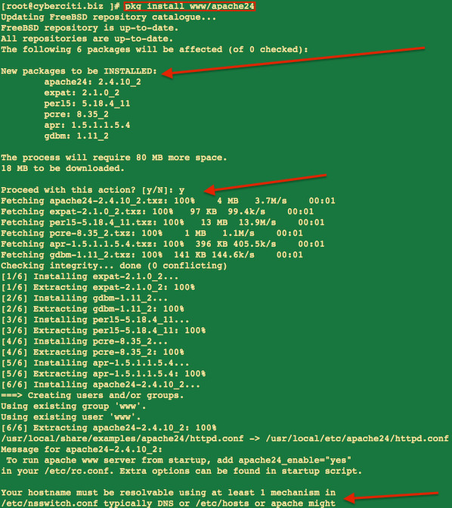

Starting up Apache service on boot
Add following to the end of “/etc/rc.conf” file to launch Apache at start up:
echo 'apache24_enable="YES"' >> /etc/rc.conf

Starting / stopping / restarting Apache server
To start Apache to make sure it works:
# /usr/local/etc/rc.d/apache24 start
To restart Apache server:
# /usr/local/etc/rc.d/apache24 restart
To stop Apache server:
# /usr/local/etc/rc.d/apache24 stop
You can also use the service command for starting/stoping/restarting Apache server on FreeBSD:
## service command to control Apache server ##
service apache24 start
service apache24 restart
service apache24 stop
service apache24 status
Sample outputs:
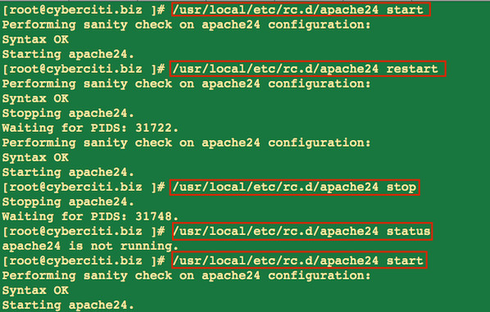
Note: If you are getting this error “Could not reliably determine the server's fully qualified domain name, using 127.0.0.1.” Set the ‘ServerName’ directive globally to suppress this message:
Add next line to /usr/local/ect/apache24/httpd.conf file:
ServerName localhost
Replace localhost with the server’s domain name which can be obtained with:
# hostname -f

Setting up MySQL server
The package or port to be installed will depend on available MySQL version. As of this writing, the maximum available version is 5.6.

Install MySQL server
To install the port:
# cd /usr/ports/databases/mysql56-server/ && make install clean
or, to add the package:
# pkg install databases/mysql56-server
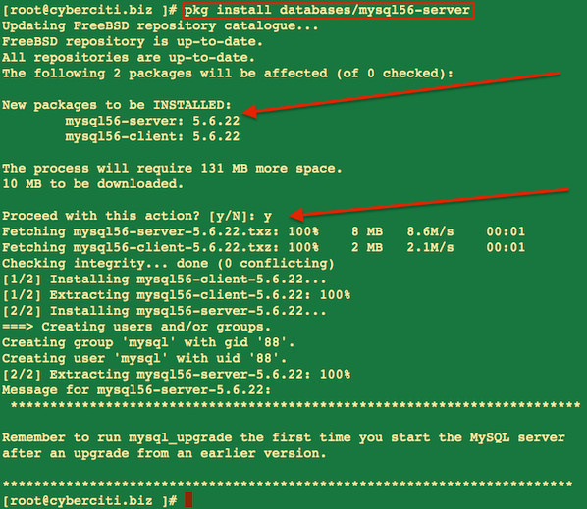

Install MySQL client
To install the port:
# cd /usr/ports/databases/mysql56-client/ && make install clean
or, to add the package:
# pkg install databases/mysql56-client

Starting up Mysql server service on boot
Finally, /etc/rc.conf must contain the following line to allow the MySQL server to start:
echo 'mysql_enable="YES"' >> /etc/rc.conf

Starting / stopping / restarting Mysql server
To start the Mysql server type:
# /usr/local/etc/rc.d/mysql-server start
To restart the Mysql server type:
# /usr/local/etc/rc.d/mysql-server restart
To stop the Mysql server type:
# /usr/local/etc/rc.d/mysql-server stop
You can also use the service command for starting/stoping/restarting mysql server on FreeBSD:
## command to start/stop mysql servers on a FreeBSD 10 ##
service mysql-server start
service mysql-server restart
service mysql-server stop
service mysql-server status
Sample outputs:
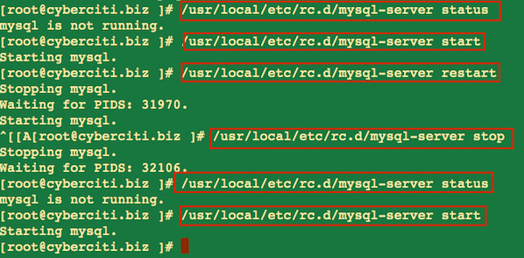

Setting up Mysql server passwords
The default is set to allow anyone to have full access. It’s very important that you set up passwords. To set a password on the anonymous accounts use:
# mysql -u root
Run the following sql queries at mysql> prompt (replace host_name with actual system host name which can be obtained with hostname -f command:
mysql> SET PASSWORD FOR ''@'localhost' = PASSWORD('newpwd-here');
mysql> SET PASSWORD FOR ''@'host_name' = PASSWORD('newpwd-here');
mysql> quit
Bye
To set a password for the root account use:
# mysql -u root
Run the following sql queries at mysql> prompt:
mysql> SET PASSWORD FOR 'root'@'localhost' = PASSWORD('newpwd-here');
mysql> SET PASSWORD FOR 'root'@'host_name' = PASSWORD('newpwd-here');
mysql> quit
Bye
NOTE: An alternative method to set a password for the MySQL root user is to run the following command:
/usr/local/bin/mysqladmin -u root password 'PASSWORD-HERE'
See “MySQL Change root Password” tutorial for more information.
After setting the password, here is how you shutdown mysqld server:
# mysqladmin -u root -p shutdown
Sample outputs:
Enter password:

Tip: If you “forget” the root password, here is how you can reset it
Stop mysqld with this command:
# /usr/local/etc/rc.d/mysql-server.sh stop
Modify the start command to add this option to the command line. Do not leave this option on for long. Only for when you need it. It bypasses all usual mysql security:
-Sg|--skip-grant-tables
This option causes the server not to use the privilege system at all. This gives everyone full access to all databases! (You can tell a running server to start using the grant tables again by executing mysqladmin flush-privileges or mysqladmin reload.)
Modify it in /usr/local/etc/rc.d/mysql-server.sh:
/usr/local/bin/safe_mysqld --user=mysql --skip-grant-tables > /dev/null & && echo -n ' mysqld'
Start mysqld:
# /usr/local/etc/rc.d/mysql-server.sh start
Connect to mysql:
# mysql
Look out because this next step will reset the passwords for all root users. Make sure that’s what you want to do. You may wish to restrict this SQL by including an “and host = ‘something'” clause. Inspect existing users with “SELECT host, user from user;“. Select the mysql database and reset the password:
mysql> use mysql
mysql> update user set password = PASSWORD('secret') where user = 'root';
mysql> quit
=> Do not forget to undo that mysql bypass i.e. Stop mysqld with: /usr/local/etc/rc.d/mysql-server.sh stop
=> Remove the option from the vi /usr/local/etc/rc.d/mysql-server.sh and remove --skip-grant-tables options.
=> Restart mysqld with: /usr/local/etc/rc.d/mysql-server.sh start
=> See “Recover MySQL root Password” tutorial for more information.

Install PHP
When you build PHP, you need to add the configuration option so that PHP build includes support for the Apache server. Type the following commands:
# cd /usr/ports/lang/php56
# make config
When the menu comes up to select/deselect various build options. You should select:
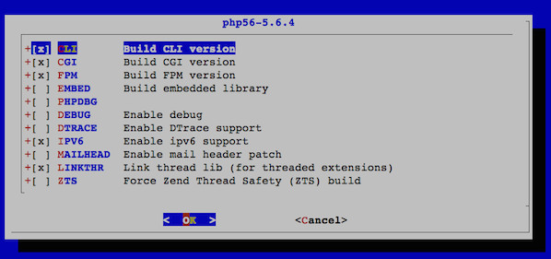
Now you will do the make clean command. I normally do these commands all in one but to get the configuration menu, I do them apart.
# make install clean

Install mod_php for Apache
Type the following commands to build mod_php for Apache:
# cd /usr/ports/www/mod_php56
# make install clean
Sample outputs:
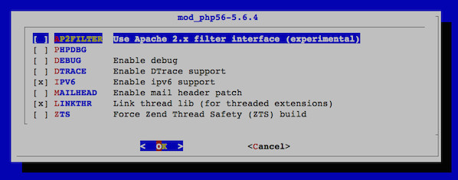

Install php extensions
If you aren’t sure if it’s or you didn’t check it with your MySQL install, you will do it the commands the same way so you get the menus to configure to add support for both MySQL and MySQLi to communicate with the MySQL server.
# cd /usr/ports/lang/php56-extensions/
# make config
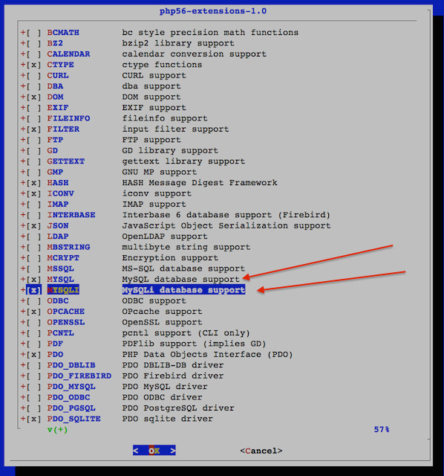
You may also select other extensions as per your PHP apps requirements. Then finish up with:
# make install clean

Configure mod_php
To configure it you will type the following command that just makes a copy of a file:
# cp /usr/local/etc/php.ini-development /usr/local/etc/php.ini
To configure Apache and open the file:
# ee /usr/local/etc/apache24/httpd.conf
I use ee (feel free to use vi or Emacs) text editor for simple edits, look for this line:
DirectoryIndex index.html
And change it so it reads as follows:
DirectoryIndex index.html index.htm index.php
Find and set the following values as per your domain, IP, and port number:
ServerAdmin webmaster@cyberciti.biz
ServerName www.cyberciti.biz:80
Listen :80
Save and close the file. Create a file called /usr/local/etc/apache24/modules.d/001_mod_php.conf as follows:
# cat /usr/local/etc/apache24/modules.d/001_mod_php.conf
<FilesMatch "\.php$">
SetHandler application/x-httpd-php
</FilesMatch>
<FilesMatch "\.phps$">
SetHandler application/x-httpd-php-source
</FilesMatch>
Now restart Apache server:
# /usr/local/etc/rc.d/apache24 restart
OR
# service apache24 restart

Test your setup
Create a file called /usr/local/www/apache24/data/test.php:
# vi /usr/local/www/apache24/data/test.php
Append the following code:
<?php
phpinfo();
?>
Save and close the file. Fire a web-browser and type the url:
http://your-domain-name/test.php
http://your-ip-address/test.php
Sample outputs:
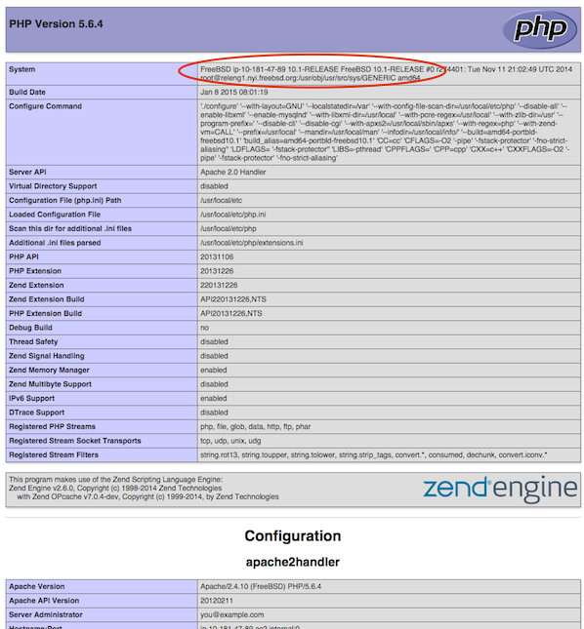

How do I secure PHP?
See our 25 PHP Security Best Practices For Sys Admins for more info.

Recommended readings
- Apache HTTP Server Version 2.4 Documentation
- man pages – httpd(8), service(8)
This quick tutorial was contributed by Wendy Michele. Editing by admin. You can too contribute to nixCraft.

Posted by: Vivek Gite
The author is the creator of nixCraft and a seasoned sysadmin, DevOps engineer, and a trainer for the Linux operating system/Unix shell scripting. Get the latest tutorials on SysAdmin, Linux/Unix and open source topics via RSS/XML feed or weekly email newsletter.

